MKT716 analytics and databases
Database and Analytics Plan: Music Streaming

10657770

Word count: 5,304

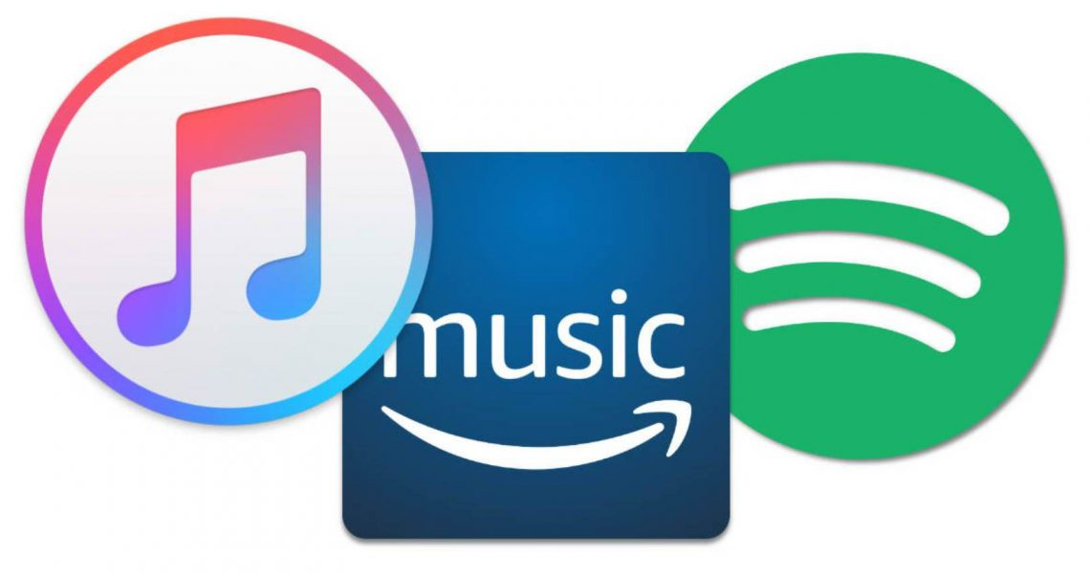
Table of Contents

1. Executive Summary 3
2. Introduction: Context and Sector Selection 3
2.1 Music Streaming 3
2.2 Introduction to Spotify 4
3. Data Sourcing 5
3.1 Sources 5
3.2 Channels 7
Figure 1: Spotify Discover Weekly Data Flow Model 7
3.3 Tools 8
Table 1: Spotify tools (adapted from: Baer and Samuelngahane, 2019). 9
Figure 2: Spotify's 2018 ML Platform 10
Figure 3: Spotify's 2019 ML Platform 10
4. Data Crunching 11
Figure 4: Big data impact (Lee, 2017). 12
Table 2: Three types of data and how music streaming harnesses them. 12
5. Insights from Data and Uses of Insights 13
Table 3: KPIs, metrics and properties. 13
Table 4: Evaluation of insights 14
5. Effective and Efficient Data Management 14
Table 5: Data Value Chain: process of collecting data through social networking on music streaming platforms (adapted from: Open Data Watch, 2019). 15
Table 6: GDPR key principles and music streaming accordance 15
Table 7: How Spotify uses vectors and top terms with assigned weights - example of keywords (adapted from: Whitman, 2012). 17
Figure 5: Social Media Model (Complete Outsourcing, 2019). 17
6. References 19
7. Appendices 23
Appendix A: 23
Appendix B 24
Appendix C: 27
Appendix D: 28
Appendix E 29
Appendix F: 30
Appendix G: 31
Appendix H: 32
Appendix I: 33
Appendix J: 34

Executive Summary
Databases and analytics can be defined as the “process of examining data sets in order to draw conclusions about the information they contain, increasingly with the aid of specialised systems and software.” (Rouse, 2008). Sourcing, crunching, and analysing the metrics from the insights using data management systems is not yet mastered, although applied increasingly as the world is becoming smarter (Marr, 2015).

Big data, a mass amount of data, is described as the new gold, oil and plastics (Cuban, 2017), and “reaps commercial benefits” (Aquila, 2016). It is transforming society; conducting science, improving performance and operating business (Marr, 2015). It is argued that the world is experiencing the “digital revolution” (Oracle, 2019), and it is more important for businesses and organisations to take advantage of Big data. It is accumulating into larger amounts; in 2018, Intel anticipated that “by 2020 […] the average consumer will generate 1.5 gigabytes of Data per day from their associated internet activities” (Hemann and Burbary, 2018), and this was underestimated as in 2019, it is has exceeded at 2.5 quintillion bytes of data that is generated daily. Almost all the global data has been produced in the last 2 years (Rai, 2019).

This essay will act as a consultancy for music streaming with justified suggested improvements to the data management systems. Streaming is the fastest growing area within the music industry that opens doors for customer insights (Music Streaming Insights, 2018), with subscription streaming being a key driver in revenue and data (Aquino, 2019). Currently, music streaming outsources and employs third party tools but merely touches on internal pioneering technologies, as well as relying too much on insights that are not unique or in-depth. There are more opportunities, and this essay will argue, focusing mainly on Spotify, how internal social networking tools on the own channels will benefit music streaming in engaging more customers, becoming more personalised for users and an increased revenue.

Introduction: Context and Sector Selection
Music streaming, Big data and analytics can assist in learning and research, however, there are issues that need to be recognised and resolved; businesses are not harnessing Big data to optimum performance despite their current usage (see Appendix A). There are issues relying too much on data management platforms, misleading data, and complicated models. 90% of Big data is unstructured (Ahmad, 2017), thus the importance of correct data management.

2.1 Music Streaming
Within the music industry, music streaming, is harnessing the channels, tools and sources to “find [the] next stars, [be] aware of trends and make money by releasing music the fans want” (Setaro, 2019). The industry reaches more customers on their applications and websites as users sign up for access to a database of music, and the artists and labels of the songs aim to achieve a more mass audience on the platform. Music streaming could be argued as a partnership where both parties aim for the same goal; conversions and higher revenue, “some labels treat revenue from interactive music streaming as a licensing deal” (Billboard, 2011). For platforms like Spotify, the service can be profitable (Hollister, 2019), which is not the case for other services such as Apple Music which gains revenue, but does not turn profits (Niu, 2018). This could be argued that Apple is not fully grasping Big data and the benefits of analytics to market. With that said, even Spotify relies on other platform operators that are within the same market (Niu, 2018), and therefore, more innovative data management would be beneficial.

Spotify is not in the music space, but in the moment space (Seabrook, 2014), as it uses song analytics, and user data to help human and A.I. curators select appropriate songs for certain activities and moods through the insights that are detected. Spotify then builds playlists for those certain moments. The question of “are you playing music, or is the music playing you?” (Graham, 2018) raises questions of the ability of analytics and databases.

The music industry’s data collection can determine what will generate the most money by examining consumer insights, rather than music bought from stores that week. For example, Logic, an American rapper, had a larger percentage of listeners to his song, 1-800-273-8255 and consumers were adding it to their personal playlist; and the song had more repeated plays. This encouraged Logic’s label to invest more money in marketing for the track and it then became number 3 on the Billboard Hot 100 as a quintuple platinum record (Setaro, 2019). “Essentially, Big data was a solution pitched and sold to the music industry as a panacea to fan engagement problems” (Graham, 2018) and it also reveals how to obtain more value from customers.

Additionally, another reason for music streaming services to harness Big data is that artists can tailor their setlists to individual cities with analytics. Spotify uses granular data to identify specific preferences of its city-specific fanbases (Wang, 2019). This personalisation increases value, and music streaming services can act on insights accordingly, for marketing and increasing engagement.

Streaming services such as Spotify, Apple Music, Pandora Radio, SoundCloud and Google Play accumulated $11,509,000 in revenue in 2019, with an expected annual growth rate, CAGR 2019-2024, to be of 6.2% which will then bring the market volume to $15,520,000 by 2024 (Statista, 2019). Appendix B displays how some of the market leading streaming services deliver their use and devices.

There are issues such as the digital eco systems that have been created by the “rapid and relentless introduction of new platforms, tools, data sources, and media distribution vehicles” (Hemann and Burbary, 2018). There is now so much data that is available that provides insights and identifies, anticipates and satisfies (Chaffey and Ellis-Chadwick, 2019), customer needs and generates financial benefits; nevertheless this makes it more complicated with how to source and crunch data and select tools to gather data. Additionally, content creators are not fully aware of the importance of data and data management, therefore this can have a knock-on effect of miscommunication to the public, through marketing campaigns, because of inaccurate data or inefficiencies (IPO, 2019).

2.2 Introduction to Spotify
Spotify, the world’s biggest music streaming platform in terms of the number of its subscribers (Iqbal, 2019), is a freemium model that gives access to consumers who sign up for free, accompanied by adverts, and those who pay a monthly subscription have premium access to an unlimited amount of plays and skips. The foundations of Spotify were created when Daniel Ek and Martin Lorentzon sought to create a legal digital music platform when the challenges of online music piracy were rife in the early 2000’s, and now it dominates how consumers listen to music in the 21st Century (Iqbal, 2019). Spotify has competitors of Apple Music, Tidal and Pandora and other services, which ensures rivalry within the market and thus a battle for Big data and unique insights from the tools, channels and sources. A.I. and machine learning within the music streaming sector is particularly in Spotify’s domain with recommended songs, discover weekly playlists and calculated top songs within that year for each listener that compiles into a personalised playlist. Spotify are continuing to personalise their service for customers, but missing crucial language and sentiment tracking that could engage customers more.

Spotify claims that they are a data-driven company (Spotify, 2013). The service has multiple uses of data using Kafka for the collection, Hadoop for processing and other databases for the analytics and visualisation (see Appendix A). Spotify recognises that over time it has advanced in recommendation features (Spotify Labs, 2019), and now gradually uses more tools to analyse data and achieve more personalised marketing. This has not fully been recognised yet with complications still in their pathways, and data lakes; choosing the correct sources for the data leads to more holistic results and better evaluation of customers (Blades, 2019).
.

Data Sourcing
Any industries adopting Big data need to be aware of where they will get that data from.
Since the innovation of music streaming, services have entered into the market that are constantly shifting to establish new ways to expand user-base, development of products, grow revenues and obtain a sustainable long-term business model while in the competitive environment (Soundcharts, 2019). There are over 200 services that offer music streaming capabilities all fighting for methods to be the priority service for consumers, thus the mining and analytics of data to create personalised experiences, targeted preferences and the most relevant music for consumers is paramount to being successful (Soundcharts, 2019).

Spotify, the pioneer brand (Soundcharts, 2019), in particular stands by the notion of “build it ourselves” (Spotify, 2013) using both internal and external sources, channels and tools for data; “cross-functionality and autonomy of teams being the core of Spotify engineering culture” (Baer and Samuelngahane, 2019). For example, it gathers user-generated data, real-time and historic, along with external sources as a workflow manager with tools such as Luigi and also social media data. Spotify “acquire[s] data points, it’s using that information to train the algorithms and machines to listen to music and extrapolate insights that impact its business and the experience of listeners.” (Marr, 2017).

The Big data they collect can be compelling, for example, in 2013 “Spotify used streaming data to predict the Grammy Awards winners. Spotify did this by breaking down its users’ listening habit, considering song and album streaming, to determine the popularity of the music. In the end, 4 out of the 6 predictions made by Spotify turned out correctly” (Datafloq, 2019). This could be more accurate, with a higher predicted percentage, with internal sources and tools analysing qualitative data.

Sources
“Data is coming from new sources to give us an even more vivid picture of how music is discovered, shared and enjoyed” (Langkjær‐Bain, 2018).

The music streaming sector use both internal and external sources when it comes to data mining and exploring data warehouses with digital ecosystems of extensive Big data. This is to be “intuitive and personalised, feeling in tune with a user’s taste and listening profile, those users are more likely to engage with the artists suggested to them. ‘This is where Big data comes into the picture: to create a service that feels personal for millions of people, you have to analyse each and every one of those people” (Langham, 2015). For example, “Spotify knows what time of day users listen to certain songs, and in many cases their location, so programmers can infer what they are probably doing—studying, exercising, driving to work” (Seabrook, 2015). Additionally, “programmers also hope to learn more about listeners by factoring in data such as what the weather is like, what your relationship status is now on Facebook” (Seabrook, 2015). Sourcing data strategically can enable services and business such as Spotify to automatically know both the music and the listener and put music in place with more context. The music streaming industry relies mainly on quantitative data such as the number of listeners, likes, shares which is argued to hold extraordinary data and unrivalled in the industry (Bly, 2020). Qualitative data, on the other hand, to analyse keywords and its use is something that was predicted in 2016 (Staring, 2016), yet has not been fulfilled. This may be because qualitative data is more complicated to source and crunch. However, this can be made easier with internal tools on the platforms.

Music streaming gathers data from user-generated data which occurs on the platform itself. For instance, Spotify gathers payment (transactional) data when users transition to a premium account, as well as collected personal data for account registration (Spotify, 2019). Spotify also gathers data from third-parties, such as social media and search, with activity from other platforms: this multi-channel method is anonymised and aggregated for IT, research, data analysis, creating marketing, promotion models, new features, functionality and improving the service that customers get (Spotify, 2019). Additionally, while Tidal collect similar user-generated data, they also collect user content that users upload onto the application with geotagging and comments (Tidal, 2019), this gives them more competitive advantage.

Secondly, raw data is accumulated via downloads, apps, and online searches influences what songs are marketed and sold and which songs become hits (Moon, 2017).

There are many ways that music streaming services collect user-generated data, and looking at four services; Spotify, Tidal, Soundcloud and Apple Music, it is clear of both the similarities and differences (see Appendix B); all which face challenges with their strategies.

Additionally, Amazon Prime employs an interactive speaker, an echo known as Alexa. The personalised audio player allows customers to stream songs hands-free and the technology with machine learning and voice recognition learns the customers preferences and tastes and customises music accordingly. The device, that is part of the Internet of Things; everyday objects with chips and signals that collect and communicate data (Burgess, 2018), acts like a digital personal assistant (Chermerhorn and Bachrach, 2017). The source and tool could generate between $18 billion and $19 billion in total sales for Amazon by 2021, and this is due to its data collection that enables more effective marketing for Amazon, brand and products; knowing what the customers want as well as their behaviour.

While some streaming services have technology that can benefit the business with more data outside of their initial platform, this requires a high cost and budget. Data sourcing can be made more effective with a lower cost if data is sourced on owned channels. For example, while Spotify is integrating into a more social network channel (Pusztai, 2019), there is an opening to incorporate more of a community and social tool on playlists, songs and artists on there that has not been implemented. This would give Spotify more access to data on their own channel; as well as more qualitative data which gives them competitive advantage with a wider knowledge of their customers and listeners.

Channels
Music streaming use their owned media to collect data by their owned applications and websites, for example, Spotify’s Discover Weekly personalised playlists for its users is a model they use on their own interfaces after sourcing the data from internal factors. This is presented on a flow chart that depicts the structure of how the data is sourced and supplied through the owned channel (see Figure 1).

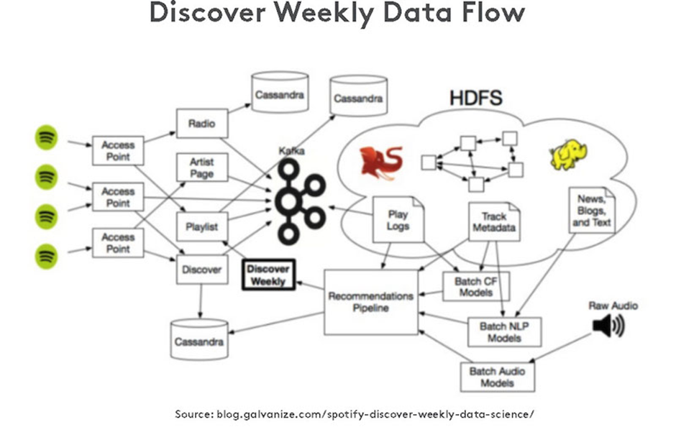

Figure 1: Spotify Discover Weekly Data Flow Model

Additionally, earned media such as social media and listening to what fans are talking about online on specific songs can be used for data collection and analysis through databases. This has been made easier for Spotify with direct connections to other tools such as Instagram stories that enable a wider reach, and another tool to gain insights. Another partnership is with PlayStation, which adds to the growing number of devices that users can access Spotify on, and another source for Spotify and its stakeholders for data mining.

Spotify also harnesses SEO. This investment can be effective, however paid channels are more efficient. For example, Spotify’s ad campaigns that are placed on Google’s paid listings, Facebook’s display sponsored ads. They are measured through the metrics and KPI’s of click through rates (CCR), pay per clicks on Google (PPC) as they remarket, and the data will be collected on how effective their campaign is to achieve customers onto their servers and listeners for the artists and labels.

A disadvantage is that new platforms are emerging all the time, and people’s desire for data changes (Cho, 2019). “A great example is Twitter. People cared so much about Twitter in the past. Now, not many people care about that, and people care less about Facebook friend counts as well” (Setaro, 2019).To achieve data from the channels effectively, tools must then need to be chosen appropriately for the type of data sourced, and kept up to date with consistent development. To avoid this limitation, the music streaming industry would benefit from using their own channels more extensively.

Tools
Spotify has always experimented with various tools for analytics. In 2019 into 2020, machine learning is a key process that is being used to predict, and this is constantly being developed (see Table 1). For example, Spotify uses machine learning to recommend songs with its Discover Weekly and Recommended for Today playlists that is personalised to a user’s activity, and Year Wrapped at the end of the year delivers insights to the user on what their favourite songs to listen to was for that year and how many hours they’ve played these songs and artists.

The constant development of tools gradually makes it easier to pave roads and create pathways that are smaller and simpler to lead onto the next tool. The difference between 2018 and 2019 is clear when seeing how developed Spotify’s Machine Learning Platform infrastructure has developed (see Figures 2 and 3). In 2020, Spotify has hopes for including Kubeflow components to their machine learning Paved Road; this includes using the cloud, an external source.

Additionally, it is increasingly popular for businesses and services to augment their own data with third-party providers that they purchase. It is estimated that in 2017, US companies spent more than $10 billion on audience data from external sources (Hemann and Burbary, 2018). Data visualisation tools make it easier to visualise and extract data from its masses.

Contrastingly, Google Music Play has the advantage of Google’s established systems, “just like Gmail allows Google to mine data from the contents of email, file attachments to the email and files stored in the same folder as the files that are attached to the message being scanned, Google Play will use music as a honey pot to draw users to the data mining machines” (Castle, 2014). Spotify also uses Google’s tools for some of their analytics, and Google Cloud is the primary collaboration; Tensorflow and Python both also being important.

Social listening tools are also increasingly used within the music streaming sector to help learn who the audience is, what content they engage with; sharing, liking, commenting, and where they can be reached on which channels and how long they are spending on each one (Hemman and Burbary, 2018).

Another tool for certain music streaming businesses is to collect from an audio footprint, and Shazam is one innovative application for doing so, “before everything went digital, data on music consumption was based on weekly store sales and radio airplay. Now, streaming services and other tools such as Shazam provide a granular, real‐time view of what audiences are listening to” (Langkjær-Bain, 2018). Shazam uses a spectrogram to gain real-time analytics without engineering. Shazam, utilising Splunk, is a platform that can recognise music playing in the background, during a night out or on the TV (McDonald, 2016). Owned and developed by Apple, Shazam has access to a “treasure-trove” of data and celebrated 15 million song identifications each day in 2013 (McDonald, 2016). Shazam has been known to predict the next big artist. This tool that Shazam has initiated can analyse what generates the most interest using their own consumer behaviour (Datoo, 2013).

While cross-channel marketing is used and therefore data is collected between various platforms, the Internet of Things is a tool that is being used in the music streaming sector but not used with the knowledge of its potentials. It is estimated that by 2020, there will be “20 billion connected things” (Bludov, 2019). There are home speakers, wearables and smart home devices for streaming, like Alexa or Microsoft’s Cortana, but this has not been used to a further degree. Furthermore, a tool known as Prism has one aim; to choose the perfect music to play at specific moments. It can recognise voices in the room and understand the behaviour of the user to then play appropriate music as it learns and remembers habits and the context of the actions (Stereoklang, 2016). There are beginning to be more devices and tools that inhabit this on the market, and the music streaming industry should be wary of this and adopt them; for businesses with a higher budget in product design and marketing.

While there are many tools that the music streaming sector is utilising, there is still a lack of understanding and complicated models being used (see Figure 2 and Figure 3). This can limit scope for businesses to use data to its full potential. Moreover, while the Internet of Things is innovative, there are other methods for sourcing and analysing data that is more cost and time effective.

Table 1: Spotify tools (adapted from: Baer and Samuelngahane, 2019).
Use | Tool
Machine Learning | - Google’s Tensorflow: TFRecord and tf.Example  - Google’s Kubeflow:
Data Pre-Processsing | - Scio  - BigQuery  - Hadoop
Feature Transformation | - R  - Featran
Model Training | - TensorFlow  - MLLib  - Keras  - PyTorch  - Scikit-learn  - XGBoost
Model Evaluation | - Noether
Model Serving | - Zoltar
Data Processing library | - (API’s) Apache Beam and Google Dataflow – Scio:  - Featran: Feature engineering  - Noether – Mordel evaluation  - Zoltar – Connected trained models with JVM-based library Apollo  - Apollo – Spotify’s production services
Programming | - Scala: builds high-performance systems with easy access to huge ecosystems of libraries (Scala, 2019).  - Python: assists to integrate systems (Python, 2019).  - Paved Road
Personalisation | - Cassandra: stores user profile attributes and metadata about entities like playlists and artists  - Kafka: producers running on different services and emitting different kinds of events like completion of a song and delivery of an ad impression  - Storm: real-time event processing  - Crunch: for running batch map-reduce jobs  (Mishra and Brown, 2015)

Figure 2: Spotify's 2018 ML Platform
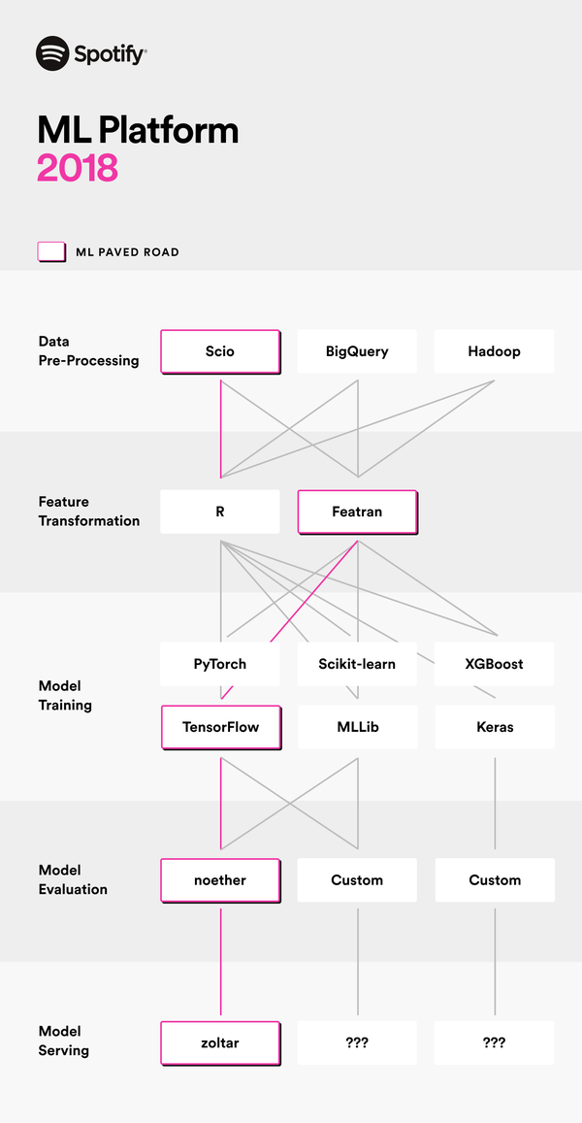

Figure 3: Spotify's 2019 ML Platform

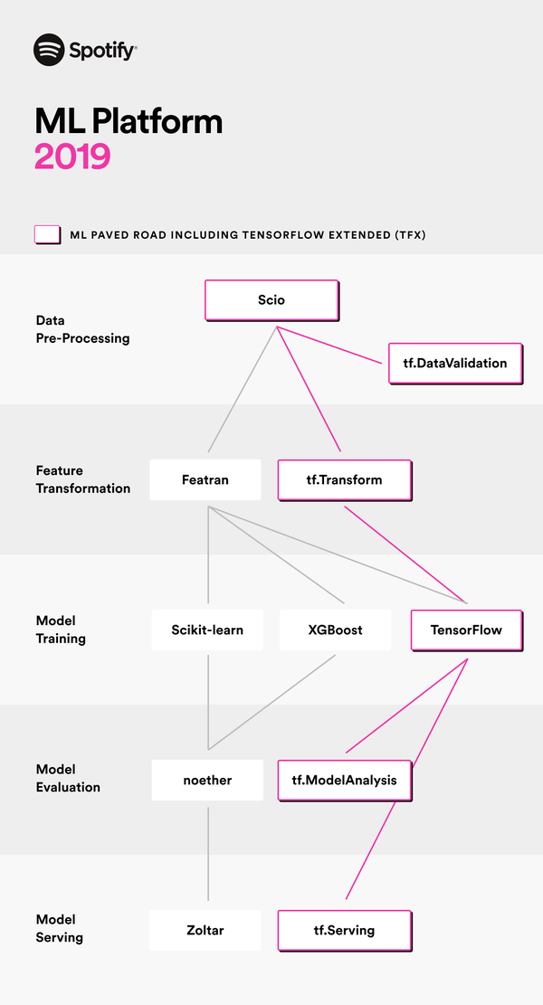

Data Crunching
Once data has been extracted, it must be crunched so it becomes useful when making marketing and business decisions (Wilson, 2006). “The traditional metrics like sales told us a record or CD was sold, but nothing about what happened after that,” (Smernicki, 2019). With more metrics and insights now, the growing volume, velocity and variety of data, which gains higher value but decays quicker, (see Figure 4), has exceeded the amount that is possible for humans to manage without sources, channels and tools (Scagliarini, 2016). When it comes to data crunching for marketing the business and service, tools must be used to obtain data that is relevant and not decayed while also making the numbers make sense. It is viewed that Big data holds no value without data crunching (Newman, 2017).

Crunching can be effective from in-depth analysis through data warehousing to data mining. For example, crunching showed that Latin artists were over-performing on Facebook, so more investment was put into the marketing on Facebook for Latin artists as the data showed it had an advantage to their target audience (Setaro, 2019). Furthermore, music sales, BDS counts of radio plays, and the Billboard charts crunch the numbers using databases to discover potential hits, help advance careers and determine the sound of music (Setaro, 2019).

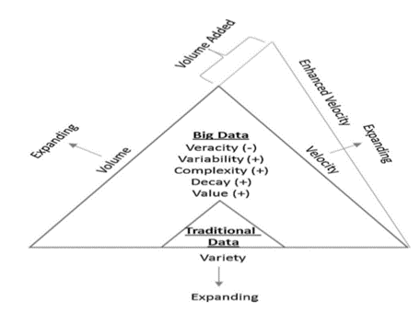

Figure 4: Big data impact (Lee, 2017).

Data crunching within music streaming is used variously and can give different types of data (see Table 2). Currently, most music streaming services search through the internet, through various sources, channels and tools, but tracking artist’s popularity and fan engagement on YouTube and multiple platforms can be complicated for record labels, talent scouts and different businesses within music streaming to analyse. As an example, Katy Perry, a famous pop artist, has about 19,000 different signals for different platforms and territories. It can be a challenge to turn the signals into useful information (Shubber, 2014); different social networks and channels have various demographics, characteristics, and consumer profiling to be targeted.

Moreover, the internet is taking power away from record labels but it’s also giving them the ability to predict future hits amongst other metrics (see Appendix C and D).

Table 2: Three types of data and how music streaming harnesses them.
Descriptive | Prescriptive | Predictive
- Algorithms  - Music streaming services deliver stickier playlists  - Analyses visits to various playlists  - Online music consumption | - Listening habits  - Suggestions of playlists, songs  - Social Listening  - Unstructured and structured | - Indirect and direct signals  - artists building a following through social media  - Companies track and control over various platforms  - AI and machine learning  – recommended playlists and songs

Insights from Data and Uses of Insights
While Amazon Prime has innovative ways of obtaining more data, particularly with Alexa, research suggests that “it’s all about the contextual understanding of the listener” (Jehan, 2020) and personalisation. Currently, music streaming collects data for various insights such as the geographical location of listeners for certain songs, gender, age, and this can help to target audiences more effectively for marketing and the service itself. However, impressions and engagement are currently not calculated effectively (see Table 3) and click through rates are not efficient to measure audio when devices are usually placed in consumers’ pockets (Blattberg, 2015). This can lead to marketing to the wrong target groups, segments and demographics.

Patterns and movements of consumer behaviour presents insights that gives a business more creativity, and artists and labels more opportunity to add content that is more engaging. On the other hand, there are flaws; “you’re going to end up in this loop [where] everything sounds like Drake and Ariana Grande,’ since everyone would only want to chase what’s already popular” (Setaro, 2019).There is an argument that insights can control too much of what music becomes a hit, and it is said that through metadata archives there is misleading analysis that creates a culture of mainstream listeners rather than encouraging subgenres and a wider range of music to be experienced (Lucero, 2020).

Insights and the way they are currently sourced have positives and negatives, (see Table 4) and alternative methods will be argued and justified in the next section.

Table 3: KPIs, metrics and properties.
KPIs | Properties
Click Through Rate (CTR) | - Measures amount interaction of clicks with song, album, artist, playlist  - Difficult to measure metrics for audio
Impressions | - User-generated data  - Location  - Demographic  - Not all music streaming services have the data open-sourced  - Can not be targeted
Engagement | - Can measure how long consumers are spending on playlists etc  - Music streaming services are not utilising likes, follows, comments that are featured on social networks

Table 4: Evaluation of insights
Evaluation of Insights | Pros | Cons
Open Source | - Free for business to access and share | - Less competitive advantage
Data visualisation tools | - Optimise marketing through Chartmetric, Tableau, Revelator, Next Big Sound and others | - Slow analytics – velocity increasing  - Sometimes complicated
Sentiments | - Recommender systems, characterising user behaviour, | - Too much reliance
Data extraction | - Trends and Patterns | - Too much reliance causes misdirected marketing
Data warehousing | - Big data storage for customer, competitor and consumer data | - Unstructured data  - Junk data  - Decayed data
Data Mining | - Dashboards and Scoreboards for clear analysis

Effective and Efficient Data Management
Data Management can be defined as “the development of architectures, policies, practices and procedures to manage the data lifecycle” (Weinberg, 2019). Music data has always been time-consuming and expensive to obtain, verify and manage, which meant the distribution of revenue often required collecting societies’ ‘discretion’ (Parker, 2004). Big data platform and management systems should be a solution that is specifically designed to meet the needs of one organisation (Chandrasekhar et al., 2013), there are many aspects to consider when looking at what data management systems are appropriate for a specific sector, service and business (see Table 5).

Nowadays, observations of enormous volumes of data, due to the evolution of technology and the massive exchange of information, are why music streaming currently open source and use Proprietary Software (Nereu et al., 2017). The music streaming sector, as well as using their own channels and tools, rely on third parties, open and outsourcing. Businesses like MusicBrainz offer their tools and services to big music streaming companies (Musically, 2016). However, this does not give businesses competitive advantage; if Spotify, Apple Music and Amazon Prime are all using the same data. This method can also be slow and limiting. Services such as Spotify should be adopting more social networking tools on their platforms to enable the collection of more raw data and gain in-depth insights which would be cost and time effective. Insights would be more narrative to the context of customer behaviour. They would show an in-depth analysis of sentiments, feelings, thoughts and emotions in context with the time of year, time of day, geographical location, and in context to their activities outside the platform as well as diverse dialogue from different cultures. Currently, Spotify have friend activity, but no option to interact with that notification. Implementing more interaction tools and interfaces would increase engagement and make it easier for the service to collect more quantitative data, as well as qualitative data using language processors, AI and finally this would aid the machine learning in creating a more personalised experience for customers.

On the other hand, when collecting consumer and customer data, especially in the UK, privacy and ethical laws need to be considered; to protect the customer but also the business (see Table 6). This challenge can be overcome with compliance and security, and public comments on the platform would need an opt-in button and transparency on the fact that user’s interaction on the platform would be public.

Table 5: Data Value Chain: process of collecting data through social networking on music streaming platforms (adapted from: Open Data Watch, 2019).

 | Collection | Publication | Uptake | Impact
1 | Identify | Analyse | Connect | Use
2 | Collect | Release | Incentivize | Change
3 | Process | Disseminate | Influence | Reuse

Table 6: GDPR key principles and music streaming accordance

Key Principles to note: | Music Streaming Services
Lawfulness, fairness and transparency | - Terms and Conditions stated  - Privacy Policy stated  - Transparent on how data is collected, used and if shared, how it is shared
Purpose limitation | - Remarketing  - Personalisation  - Purposes are limited and cannot be changed
Accountability | - Owned domain  - Third-party  - Outsourced  - Open-sourced  - Databases need to be secure and encrypted  - Tools, channels and sources need to be researched before employing them

Using a data value chain (see Table 5), the new data management and strategy can be checked and reviewed that all aspects are covered. It is important to use both data warehouses and data mining with Big data for both unstructured and structured data, however, the complicated Big data can be made easier to navigate through Oracle’s dashboard and database. Utilising Oracle for its database and dashboard would be flexible and cost effective (Oracle, 2020), and help to contextualise and narrate the data (Coombs, 2016). This would allow social listening and keyword searching easier to track and target. For example, platforms that would allow commenting and conversations on user playlists and playlists that users can follow would give freedom for the service to analyse conversations in a more qualitative method and therefore, making the service more personal for customers. Spotify will not take complete control over their data process, however, internally sourcing and in-housing the qualitative data using their own social network tools would give them competitive advantage for unique data sets and insights. Additionally, HPPC can be employed to assist with data lakes and identifying language to detect what customers are saying about certain music and the sentiments (see Appendix E).

Spotify operates natural language processing and AI to scan a songs metadata, blog posts and discussions online about news, artists and other metrics (see Table 7), but it is time consuming; it would be useful and innovative to do this on their owned channel. Spotify would be guaranteed to see a significant boost in engagement metrics and an increase in song streams through social networking tools that would also increase customer loyalty and lifetime value (Titlow, 2020).

Amazon Prime also uses recorded audio data and voice recognition, however this holds more issues with privacy laws, ethical laws and GDPR; it has been reported that data that was collected by Alexa had been leaked to the wrong customer by mistake (Statt, 2018). This increases the chances of lawsuits, and loss of money and reputation. Social networking and social listening decrease these challenges.

It can be argued that using third party tools, sources and channels can be confusing to adopt and keep up-to-date data, while data decays at a rate of 30% a year (Brence, 2016). There is uncertainty where outsourced and third-party sources may not be cleansing their databases as regularly as they should be, which also could be an infringement of GDPR in the UK. With internally sourcing and using owned channels, music streaming can avoid these challenges.

There are, of course, limitations with this data management approach, however and data ownership and data stewardship have disadvantages. Music streaming should continue employing both organisation strategies but to avoid customer criticisms on overusing data, the language processing and AI should assist in finding niche music; subgenres and not only focusing on mainstream music (see Appendix F), which has been an apprehension for many listeners and loyal customers of Spotify and other music streaming services.

To overcome these limitations and challenges, an internal social network is a source and tool that is simple yet has been overlooked; models can be imitated from existing social medias (see Figure 5). This would create a new epoch and a cultural and digital shift in allowing customers and consumers to have more of an indirect and direct influence on music, and businesses to gain advantages from social listening (see Figure 6). Customers can like, comment and interact with users they follow, as well as their friends. This community aspect will allow keyword searching and sentiment tracking and can then be used as predictive data.

Table 7: How Spotify uses vectors and top terms with assigned weights - example of keywords (adapted from: Whitman, 2012).

n2 Term | Score | np Term | Score | adj Term | Score
Dancing Queen | 0.0707 | dancing queen | 0.0875 | perky | 0.8157
Mamma Mia | 0.0622 | mamma mia | 0.0553 | nonviolent | 0.7178
Disco era | 0.0346 | benny | 0.0399 | swedish | 0.2991
Winner takes | 0.0307 | chess | 0.0390 | international | 0.2010
Chance On | 0.0297 | Iis chorus | 0.0389 | inner | 0.1776
Swedish Pop | 0.0296 | vous | 0.0382 | consistent | 0.1508
My My | 0.0290 | the invitations | 0.0377 | bitter | 0.0871

Figure 5: Social Media Model (Complete Outsourcing, 2019).
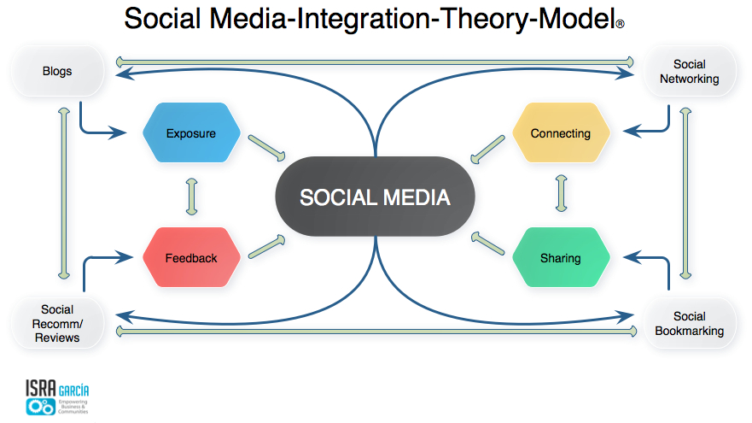

Figure 6: (Business Wire, 2019).
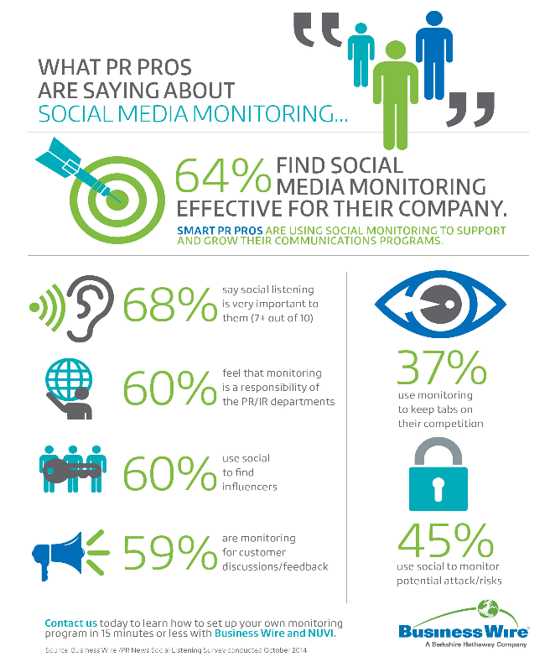

References
Aquila Insight. (2016). From Big Data to big commercial impact - Aquila Insight. [online] Available at: https://www.aquilainsight.com/blog/big-data-big-commercial-impact/ [Accessed 12 Dec. 2019].

Baer, J. (2019). The Winding Road to Better Machine Learning Infrastructure Through Tensorflow Extended and Kubeflow. [online] Labs. Available at: https://labs.spotify.com/2019/12/13/the-winding-road-to-better-machine-learning-infrastructure-through-tensorflow-extended-and-kubeflow/ [Accessed 12 Dec. 2019].

Billboard, (2020). Billboard, p.8.

Businesswire.com. (2014). Social Media Monitoring Survey Results Conducted by Business Wire and PR News Revealed. [online] Available at: https://www.businesswire.com/news/home/20141121005051/en/Social-Media-Monitoring-Survey-Results-Conducted-Business [Accessed 1 Jan. 2019].

Blades, F. (2019). How to Choose the Right Data Source. [online] GreenBook. Available at: https://greenbookblog.org/2019/09/05/how-to-choose-the-right-data-source/ [Accessed 6 Nov. 2019].

Blattberg, E. (2015). 4 things we learned about the music-streaming industry - Digiday. [online] Digiday. Available at: https://digiday.com/media/4-things-learned-music-streaming-industry/ [Accessed 12 Dec. 2019].

Bludov, S. (2019). The Rise of Internet of Musical Things. [online] Medium. Available at: https://medium.com/swlh/the-rise-of-internet-of-musical-things-ce9495770209 [Accessed 7 Nov. 2019].

Bly, A. (2019). What is the Value of Streaming Data?. [online] Spotifyforbrands.com. Available at: https://www.spotifyforbrands.com/en-PS/insights/what-is-the-value-of-streaming-data/ [Accessed 16 Nov. 2019].

Cakebread, C. (2017). Spotify and other streaming services are finally giving the music industry something to cheer about. [online] Business Insider. Available at: https://www.businessinsider.com/one-chart-shows-the-rise-in-revenue-from-music-streaming-charts-2017-9?r=US&IR=T [Accessed 6 Nov. 2019].

Castle, C. (2014). This is What Monopoly Looks Like When You Round Up to Zero: Google Play’s Tone Deaf Advertising Campaign “25 Million songs for the price of an album”. [online] Music Technology Policy. Available at: https://musictechpolicy.com/2014/08/31/this-is-what-monopoly-looks-like-when-you-round-up-to-zero-google-plays-tone-deaf-advertising-campaign-25-million-songs-for-the-price-of-an-album/ [Accessed 4 Jan. 2020].

Chaffey, D., Ellis-Chadwick, F. (2019). Digital Marketing: Strategy, Implementation and Practice. 7th Ed. Harlow: Pearson Education.
Community Links. (2020). Side by Side and Implications for Public Services. p.7.

Complete Outsourcing. (n.d.). Complete Outsourcing. [online] Available at: http://www.completeoutsourcing.com [Accessed 4 Jan. 2020].

Coombs, B. (2020). Why Your Brand Should Start Using Qualitative Data. [online] Blogs.oracle.com. Available at: https://blogs.oracle.com/marketingcloud/why-your-brand-should-start-using-qualitative-data [Accessed 4 Jan. 2020].

Datoo, S. (2013). How Shazam uses big data to predict music's next big artists. [online] The Guardian. Available at: https://www.theguardian.com/technology/datablog/2013/dec/10/shazam-big-data-prediction-breakthrough-music-artists [Accessed 30 Oct. 2019].

Hemann, C. and Burbary, K (2018). Digital Marketing Analytics: Making Sense of Consumer Data in a Digital World. 2nd Edition. Pearson Education, Inc.
Ingram, L. (2014). [online] Cultofmac.com. Available at: https://www.cultofmac.com/265655/winner-best-music-demand-streaming-service/ [Accessed 3 Jan. 2020].

Insights. (2019). The Future of Streaming - Music Industry Insights. [online] Music Industry Insights. Available at: https://insights.midem.com/music-business/future-streaming-2/ [Accessed 8 Dec. 2019].

Iqbal, M. (2019). Spotify Usage and Revenue Statistics (2019). [online] Business of Apps. Available at: https://www.businessofapps.com/data/spotify-statistics/ [Accessed 30 Nov. 2019].

Jehan, T. (2019). Personalisation in music streaming - AKQA. [online] Akqa.com. Available at: https://www.akqa.com/insight/personalisation-in-music-streaming/ [Accessed 3 Jan. 2020].

Langham, M. (2015). Spotify, Big Data, And The Future Of Music Streaming || Dotted Music. [online] Dottedmusic.com. Available at: http://dottedmusic.com/2015/music-industry/spotify-big-data-and-the-future-of-music-streaming/ [Accessed 3 Jan. 2020].

Langkjær‐Bain, R. (2018). Five ways data is transforming music. [online] Royal Statistcal Society. Available at: https://rss.onlinelibrary.wiley.com/doi/full/10.1111/j.1740-9713.2018.01106.x [Accessed 7 Dec. 2019].

Marr, B. (2015). Big Data: Using SMART Big Data, Analytics and Metrics To Make Better Decisions and Improve Performance. New York: Wiley, pp.1, 9.

McCrary, M. (2015). A Helpful Guide to Music Streaming Services. [online] XDA. Available at: https://www.xda-developers.com/a-helpful-guide-to-music-streaming-services/ [Accessed 18 Oct. 2019].

McDonald, C. (2016). How Shazam handles its data reserves. [online] ComputerWeekly.com. Available at: https://www.computerweekly.com/news/450409644/How-Shazam-handles-its-data-reserves [Accessed 22 Oct. 2019].

McDonald, M. , Mouncey, P. and Maklan, S. (2014). Marketing Value Metrics. A New Metrics Model to Measure Marketing Effectiveness. 2nd Edition. Kogan Page, London

Mishra, K. and Brown, M. (2015). Personalization at Spotify using Cassandra. [online] Labs. Available at: https://labs.spotify.com/2015/01/09/personalization-at-spotify-using-cassandra/ [Accessed 22 Oct. 2019].

Mohd, A. and Ahmad, K. (2017). Wrapper Techniques For Web Data Extraction : A Review. [online] Research Gate. Available at: https://www.researchgate.net/figure/Unstructured-Data-consists-in-Big-Data-Environment-19_fig2_322243826 [Accessed 3 Dec. 2019].

Moon, B. (2017). How data is transforming the music industry. [online] The Conversation. Available at: http://theconversation.com/how-data-is-transforming-the-music-industry-70940 [Accessed 16 Dec. 2019].

Nereu, J., Almeida, A. and Bernardino, J. (2017). Big Data Analytics: A Preliminary Study of Open Source Platforms. p.435.

Newman, M. (2017). Data has no value if it lacks a purpose - TM Forum Inform. [online] TM Forum Inform. Available at: https://inform.tmforum.org/sponsored-feature/2017/04/data-no-value-lacks-purpose/ [Accessed 3 Dec. 2019].

Niu, E. (2018). Apple Music Is Boosting Services Revenue, but Not Profits | The Motley Fool. [online] The Motley Fool. Available at: https://www.fool.com/investing/2018/04/17/apple-music-is-boosting-services-revenue-but-not-p.aspx [Accessed 2 Jan. 2020].

Oracle. (2019). pp.4, 439.

Open Data Watch. (2019). The Data Value Chain: Moving from Production to Impact. [online] Available at: https://opendatawatch.com/publications/the-data-value-chain-moving-from-production-to-impact/ [Accessed 3 Jan. 2020].

Parker, N., (2004). Music business: Infrastructure, practice, and law. Sweet & Maxwell. p.199.
Peck, R. (2017). Mark Cuban: "Data is the new gold". [online] Credit Suisse. Available at: https://www.credit-suisse.com/about-us-news/en/articles/news-and-expertise/mark-cuban-data-is-the-new-gold-201706.html [Accessed 15 Nov. 2019].

Rai, A. (2020). What is Big Data - Characteristics, Types, Benefits & Examples 2019. [online] upGrad blog. Available at: https://www.upgrad.com/blog/what-is-big-data-types-characteristics-benefits-and-examples/ [Accessed 6 Jan. 2020].

Ryan, D. (2015). Understanding Social Media: How to create a Plan for your Business that Works. 1st Edition. Kogan Page, London.

Scagliarini, L. (2016). Crunching big data: Making sense of massive data sets. [online] ITProPortal. Available at: https://www.itproportal.com/2016/06/07/crunching-big-data-making-sense-of-massive-data-sets/ [Accessed 3 Jan. 2020].

Schermerhorn, J. and Bachrach, D. (2017). Exploring management. Singapore: John Wiley & Sons, Inc., p.5.

Sen, I. (2019). How AI helps Spotify win in the music streaming world - Outside Insight. [online] Outside Insight. Available at: https://outsideinsight.com/insights/how-ai-helps-spotify-win-in-the-music-streaming-world/ [Accessed 20 Dec. 2019].

Shubber, K. (2014). Music analytics is helping the music industry see into the future. [online] The Guardian. Available at: https://www.theguardian.com/technology/2014/apr/09/music-analytics-is-helping-the-music-industry-see-into-the-future [Accessed 18 Nov. 2019].

Soundcharts.com. (2019). Soundcharts | Market Intelligence for the Music Industry. [online] Available at: https://soundcharts.com/blog/how-music-streaming-works-trends [Accessed 4 Jan. 2020].

Staring, R. (2016). Future Business Models for Digital Music Services: A Qualitative Research with Industry Experts. [online] Available at: https://pdfs.semanticscholar.org/2db2/52c0a2e3622d2ca0ec4e73ee5965a536e2a4.pdf [Accessed 2 Jan. 2020].

Statista. (2019). Music Streaming - worldwide | Statista Market Forecast. [online] Available at: https://www.statista.com/outlook/209/100/music-streaming/worldwide#market-globalRevenue [Accessed 20 Dec. 2019].

Statt, N. (2018). Amazon sent 1,700 Alexa voice recordings to the wrong user following data request. [online] The Verge. Available at: https://www.theverge.com/2018/12/20/18150531/amazon-alexa-voice-recordings-wrong-user-gdpr-privacy-ai [Accessed 3 Jan. 2020].

The Trichordist. (2018). 2018 Streaming Price Bible! Per Stream Rates Drop as Streaming Volume Grows. YouTube’s Value Gap is Very Real.. [online] Available at: https://thetrichordist.com/2019/01/29/2018-streaming-price-bible-per-stream-rates-drop-as-streaming-volume-grows-youtubes-value-gap-is-very-real/ [Accessed 21 Nov. 2019].

Ulster University. (2019) The Music Data Dilemma: issues facing the music industry in improving data management. London: Government UK, p.14.

Weinberg, P. (2019). 28 Data Management Tools & 5 Ways of Thinking About Data Management. [online] Blog.panoply.io. Available at: https://blog.panoply.io/28-data-management-tools-5-ways-of-thinking-about-data-management [Accessed 20 Dec. 2019]].

Whitman, B. (2012). How music recommendation works — and doesn’t work. [online] variogram by Brian Whitman. Available at: https://notes.variogr.am/2012/12/11/how-music-recommendation-works-and-doesnt-work/ [Accessed 20 Nov. 2019].

Appendices

Appendix A:
Spotify data use cases (adapted from: Spotify, 2013)

Use Cases | How they are used
Reporting | - Labels, licensors, partners and advertisers that supports partners
Business Analytics | - Analysing growth, user behaviour, sign up funnels  - Company KPI’s  - A/B testing  - NPS analysis  - Segmentation analysis
Operational Metrics | - Root cause analysis  - Latency analysis  - Better capacity planning (servers, people, bandwidth)
Product features | - Radio  - Top lists  - Recommendations (Internal rather than external parties because of the amount of data)

Appendix B
How Music Streaming Services Source Data (adapted from: The Trichordist, 2018).

Service/Business | Personal Data | User-generated/ activity | Third-party
Spotify | - Account Registration  - Service Usage Data  - Payment Data | - Contests  - Surveys  - Sweepstakes  - Voluntary Mobile Data | Advertisers  Partners  Social Media
Apple Music | - Display name  - Profile photo  - Other personal information on Apple personal profile  - Shortened and encrypted hashes of phone numbers and email addresses of user contacts | - Songs played  - How long songs are played  - Sync library with apple devices  - Approximate number of phone calls and emails sent and received: computes a deoce trist score when attempts of purchasing  - How user uses Apple  - Listening activity: playlists, music added to library, content user ‘loves’, comments, shares  - IP address  - Device, app, car interface used to play  - Time the song is played and how long  - User demographics: age, gender | Social media
Soundcloud | - Account information: username, email address, age, password  - Name  - Billing address  - Payment verification information  - City and country user lives in  - Profile picture, header or avatar  - Details of other websites and social media profiles and links to them  - Gender | - Information user posts: comments, community discussions  - Survey informatation  - Communications: email or platform between user and service  - Usage information: pages that user visits, links clicked on, streaming offline listening, download, uploading and recording tracks, connected to social media accounts, sharing with users, following and unfollowing users, performing a search, time, frequency and duration of visits, interaction with emails – opened, clicked on, forwarded.  - Log data: details about how user used the platform, IP address, access time, browser type and operating system, device information, event information (crashes, browser type), page user viewed or engaged with before or after using platform  - Cookies: pixels, local storage, mobile device identifiers, tracking technologies, behaviour  - Location: general location, IP address  - Device information: interaction with platform, information about device, hardware model, operating system, coockie information, device settings, movile device, advertising identifiers, apps installed, browser type, language, battery level, time zone, Apple’s iOS Advertising Indentifier (IDFA), Google’s Android Advertising ID | - Business Partners an service providers who use SDK’s: companies that assist with payment processing, analytics, advertising, marketing, data processing and management, customer and technical support, content moderation, hosting  - Interaction with content and advertisements and enabled analytics and other features through mobile devices  - Single-Sign ons: Signed through Google or Facebook collects information
Tidal | - Username  - Password  - Name  - Contact information  - Process of payments | - User content – photos, comment and other materials  - Metadata – content creation data, formatting information, location information  - Geotags – creation data, location  - Communications between user and service  - Favourites  - Playlists created  - Tracks played  - Downloads  - Time of log-in  - Versions of the application user uses  - Device and unique device number  - Log file information: browser type, referring/exit pages and URLs, number of clicks and interaction with clicks, domain names, landing pages, pages viewed  - Survey information: anonymous and aggregated responses | - Analytics tools and providers: measure traffic, usage trends – collected as a group of visitors  - Social media: Facebook, business partners, advertising networks, telecommuications providers

Appendix C:
Table depicting the types of customer and competitor data.
Customer Data | Customer media (owned and earned) | Competitor data
Reach data | Owned social media metrics | competitor
Action data | Earned social media metrics | Partner data
Conversion data | Paid search metrics
Engagement data | Organic search metrics
Competitor data
Partner data
Other data

Appendix D:
Types of analytics and their use (adapted from: Hemann and Burbary, 2018).
Type of analytics | Use with music streaming
mobile | - Applications data  - Flexible
geofencing | - GPS, RFID, Wi-Fi and cellular data with preprogramed actions and RFID tags - specific marketing  - Customisable for cultures and regions
Location-based | - Predicts areas for demand on certain music and artists  - Predictive data: planning concerts
Social media – network, interests, sentiment, influence, audience | - Social listening to find music popularity and sentiments
Web analytics | - Search, SEO, paid ads, multiple channels to find what music will make the most profit and engagement from customers

Appendix E
Data management platforms and their strong points (Nereu et al., 2017).
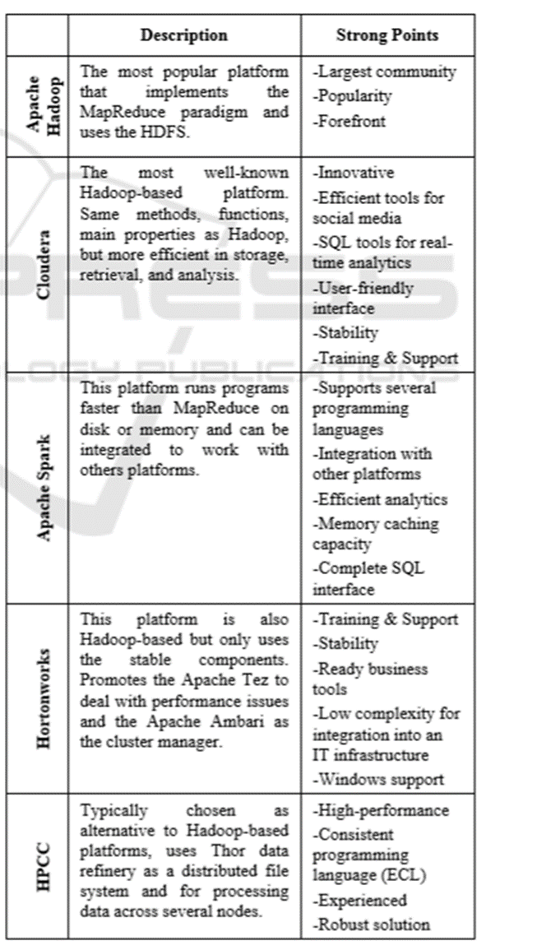

Appendix F:
Strategy and tools of data management (adapted from: Hemann and Burbary, 2018).
Strategy and tools | Positive aspects | Challenges
Data ownership | - High degree of control and expansion | - Privacy issues
Data Stewardship | - Content and metadata can be kept up to date and relevant | - Costs
Metadata | - More in-depth analysis | - Misleading and complicated
Data quality | - High quality, effective and relevant to marketing | - Difficult to find within digital ecosystems
Data usage | - Relevant and targeted for marketing and engagement | - Ethical issues
Outsourcing | - Service providers with expertise can present useful insights | - Costs and data sharing can be privacy and ethical challenge
Managing tech stack | - Technologies enables music streaming services to program langugages, various frameworks, indexes, libaries, servers etc. | - Needs skills and expertise for the tools and technologies  - Costs
New tech | - Innovative  - Competitive advantage | - Costs  - Time consuming  - Innovative breakthroughs

Appendix G:
The money streaming into the music industry (Cakebread, 2017).
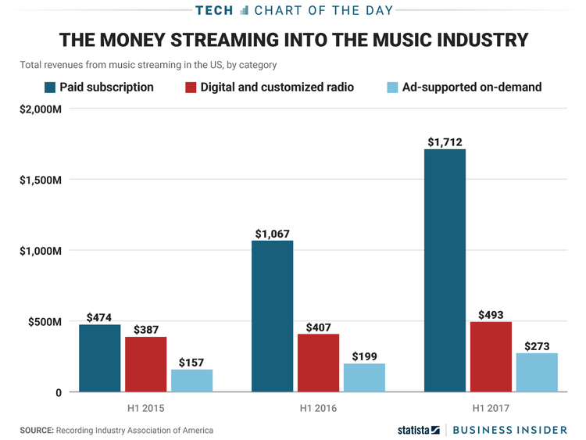

Appendix H:
Spotify Growth Timeline (Iqbal, 2019).
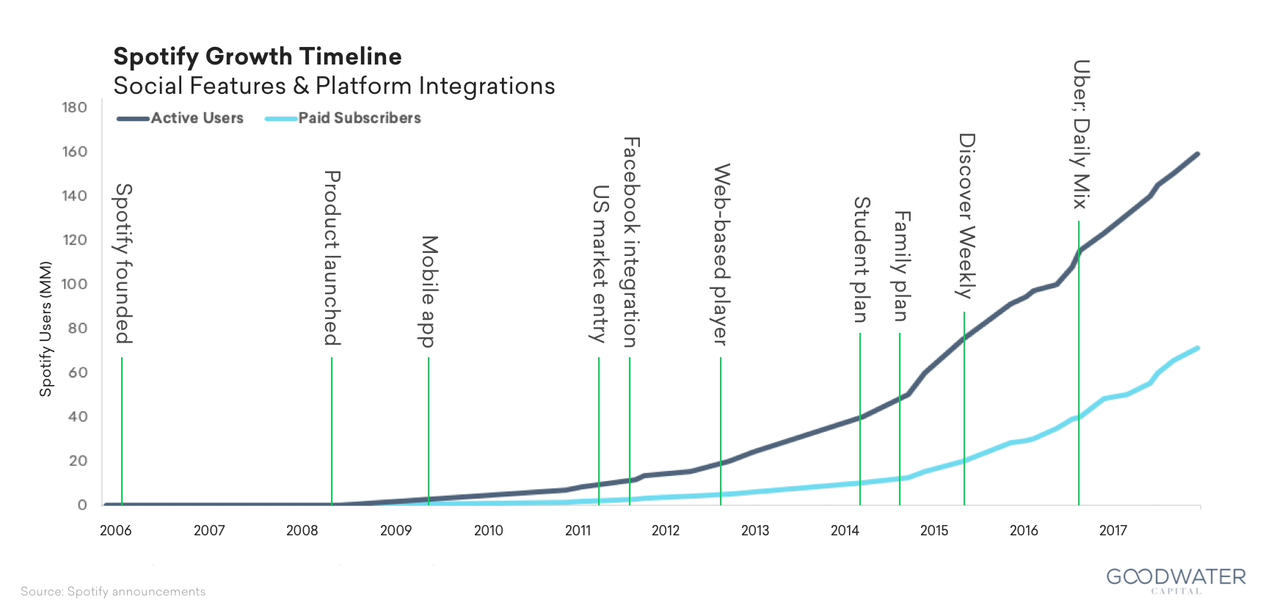

Appendix I:
Spotify MAU Growth by Geography (Spotify, 2017).
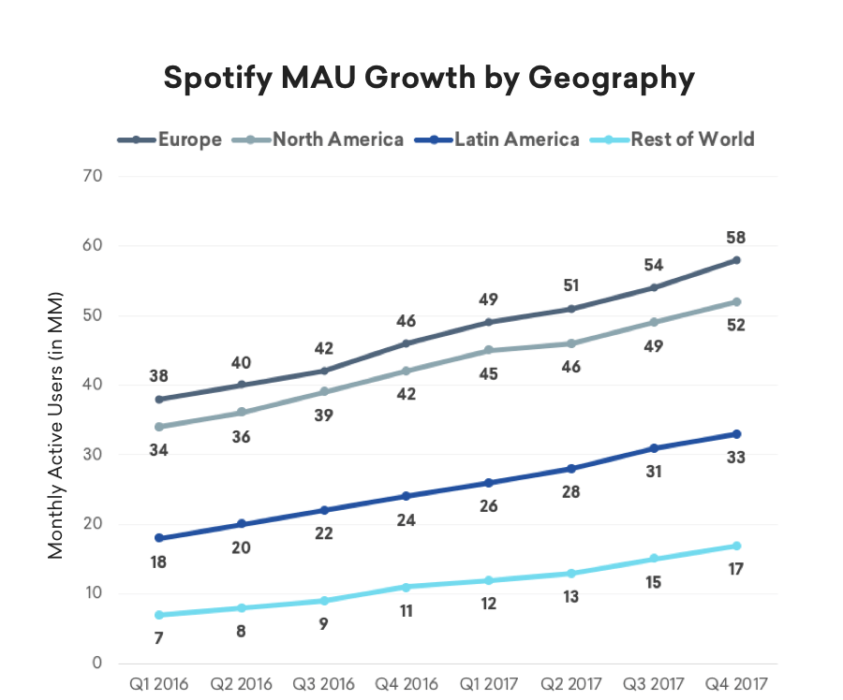

Appendix J:
Music streaming services, their properties and market shares (adapted from: Ingram, 2014).
Service | Pricing Tiers (Monthly) | Stream Quality | Catalog Size | Desktop Clients | Mobile Clients | Upload Own Library | Market Share (UK)
Google Play/ All Access | - Free  - $9/99 | - Up to 320 kbps (MP3) | - Over 30 million songs | Google Play Music for Chrome, Music Manager | Android, iOS | 50,000 tracks (free) | 6% (Statista, 2018)
Amazon Prime Music | - Free  - $24.99 | - Up to 256 kbps (MP3) | - 1 million songs (Prime music) | Web Player, PC, Mac native clients, Fire TV | Android, iOS, Kindle Fire | 250 (free) or 250,000 tracks ($24.99 year) | 18% (Statista, 2018)
Spotify/Spotify Premium | - Free  - $9.99 | - 96 kbps  - 160 kbps  - 320 kbps (Ogg Vorbis) | - Over 30 million songs | Web Player, Pc, Mac native clients, PlayStation 4 | Android, iOS, Windows Phone | N | 42%  (Statista (2018)
Tidal Premium/HiFi | - $9.99  - $19.99 | - 96 kbps  - 320 kbps  - 1411 kbps  (AAC/FLAC) | - Over 25 million songs and 75,000 music videos | Web Player, PC, Mac native clients (in beta) | Android, iOS | N | -
Pandora/One | - Free  - $4.99 | - 64 kbps  - 192 kbps (AAC) | - 1 million songs | PC and Mac (Pandora One) | Android, iOS, Windows Phone, Blackberry | N/A | -
Rhapsody unRadio/Premier | - $4.99  - $9.99 | - 64 kbps  - 192 kbps  - 320 kbps  (AAC#0 | - Over 32 million songs | Web Player, PC native client | Android, iOS, Windows Phone, Sansa Players | N/A | -
iHeartRadio | - Free | - Up to 128 kbps (MP3) | - 20 million songs  - More than 1500 live radio stations | Web Player | Android, iOS, Windows Phone, Blackberry, Kindle Fire | N/A | -

