MTK704

Branding and Marketing

Communications:
Strategic Planning Process

THE ART FUND
The National Art Pass
and
Student Pass

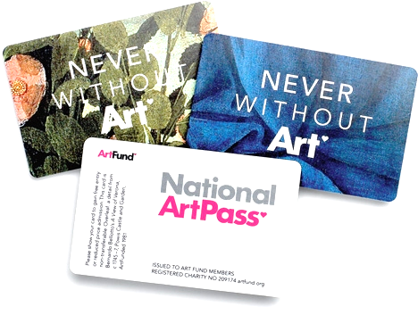
Word Count: 1549
10657770
Contents
1.Introduction 3
1.2 Background: Art fund and the national art pass. 3
2. Selecting the target audience 3
3. Understanding the target audience decision making 4
4. Determining the best positioning 6
5. Developing a communication strategy 7
6. Setting the media strategy 8
7. Improvements for the campaign 9
8. References 10
10. Appendices 12
10.1 Appendix 1: Decider participant grid with communication objectives of the art fund (adapted from Percy and Rosenbaum-Elliott, 2009). 12

1.Introduction
Within this essay, Percy and Rosenbaum-Elliott’s Strategic Planning Process will be discussed and evaluated using the Art Fund, the National Art Pass and the Student Pass.

1.2 Background: Art fund and the national art pass.
Within the past 2 years, the arts and culture industry has grown £390m in a year and now contributes £10.8billion a year to the UK economy (Arts Council, 2020). However, with more funding cuts to arts organisations and museums, (Brown, 2020), the Art Fund was given a higher target of attaining 20,000 new members every year for 2 years (Smith, 2018).
The British, non-profit organisation (National Gallery, 2020), enriches museums and galleries throughout the UK giving people wide access to art (Gov UK, 2018). In 2017, Art Fund was in a healthy position where revenue had almost doubled within recent years and the charity’s membership was at its highest (Smith, 2018). The Art Fund created the National Art Pass and Student Pass, giving consumers free or discounted access to galleries and museums in the UK. The campaign aimed to recruit new members; specifically targeting younger members, with these marketing objectives;
- Get people talking about the National Art Pass; voluntary engagement, word-of-mouth and electronic word-of-mouth
- Build an emotional connection amongst those who want to enjoy art; brand identity from charity to cultural membership organisation
- Recruit a record number of new Art Pass members; new members to increase to 20,000 per year by 2018
- Successfully launch new £5 Student Art Pass; target of 5000 passes

2. Selecting the target audience
Selecting the appropriate target audience, as a function for the brand purchase objective displayed in the marketing plan (Percy and Rosenbaum-Elliott, 2012) is crucial to adopt, otherwise higher risks in fostering brand identity that does not resonate with the customers can occur (Timson, 2019).
Therefore, the Art Fund targets a broad audience following the notion that “broad reach beats narrow targeting” (Smith, 2018); marketing approaches with a broad reach are successful when communicating a low price for the product and service offer (Porter, 2008). Also, broader reach can be a lower cost for the organisation (Marketing Evolution, 2019).
Originally, the target audience for Art Fund were defined as “culturally active and engaged adults with an interest in the visual arts”(Smith, 2018), however, the decline of acquisition rates established that a broader audience was needed; consumers with an interest in art, people wanting to visit museum and galleries but haven’t made the time to, and university students. The potential lifetime value of customers was declining after the average age of new members was increasing and retainment levels were getting lower (Smith, 2018). This was an underlying issue where in the same year, 36% of 2000 UK 18-30-year old’s never visited galleries, 24% never visit theatres and 19% never visit museums (Eccelesiastical, 2018).

3. Understanding the target audience decision making
Once the target audience has been identified and the message theme has been decided, how to reach the target is the next concern (McCalley,1996). There must be an understanding of how the target audience makes purchase decisions within the category and the behaviour that goes with this, with internal and external factors, such as increase in competitors with higher market attractiveness, and economic influences (Percy and Rosenbaum-Elliott, 2009).
Firstly, the campaign targets new customers that are within a new category of users; people searching for activities to do in London and students. This creates more competitors and potential substitutes (see Figure 1), which makes it more crucial for Art Fund to ‘cut through the noise’ and reach their target audience.
Furthermore, monetary value is a critical factor within the decision process of purchasing the Art Pass (Smith, 2018). The original Art Pass is regarded as a high involvement purchase at over £60 where the rational benefit takes forefront of consumers mind (Smith, 2018) with financial and time commitments (Percy and Rosenbaum-Elliott, 2009). The Art Pass is purchased after consideration and calculation with the consumer questioning how many times they will use it “in order to make it worthwhile, rather than on impulse” (Smith, 2018), therefore, search and conviction occurs before purchase (Percy and Rosenbaum-Elliott, 2011). However, at a lower cost of £5 for the student pass, the level of involvement is lower, thus the process is made quicker with short cuts to information search, trial and repeat purchase (Percy and Rosenbaum-Elliott, 2009). Although, often other roles influence the decision (see Table 1).
At the time of the campaign, consumers had less money to spend due to inflation increasing (Smith, 2018). Due to this, consumers were less likely to spend money on non-essentials, thus the perceived risk of purchasing an Art Pass, a luxury and non-essential purchase and gift, was higher (GfK NOP, 2017). To ensure acquisition through this economical factor, the campaign reaches the target audience with a combination of emotional and rational advertising through mix marketing for broad breadth (Moore and Moore, 2014); print media, film and digital media (Smith, 2018). Emotional increases the sales, and both emotional and rational together increase the percentage of new customers (Binet and Field, 2018).
To encourage repeat purchase, Art Fund initiated a trial. Afterwards, word-of-mouth and free, earned promotion between C2C, B2B, and B2C increases retention and enhances inclination, conviction and favourable attitude towards the brand through attitudinal loyalty (Martinez-Ruiz et al., 2018). Furthermore, the campaign also offers £10 Art Pass for 3 months each summer that aims to convert over 10% of trialists to full members in the autumn of each year using product benefit (Smith, 2018). This increased brand recall in all areas of chosen media, brand awareness and an increase in website visits and unique visits (Smith, 2018).

Figure 1: Porter’s 5 Forces in terms of Art Fund’s National Art Pass Campaign; an example.

Table 1: Student Pass Behavioural Sequence Model using the marketing and buyer behaviour purchase decision model
 | Problem recognition | Information search | Evaluation of alternatives | Decide on National Art Pass | Purchase a National Art Pass
Individuals involved and decision roles | - Self, Family and peers (other students) as initiators and influencers | - Self, Family and peers (other students) as influencers | - Self as decider  - Parents as influencer  - Friends and peers as influencer | - Self or parents as decider | - Self or parents as purchaser
Where stage is likely to occur | - Home  - Friends  - Exposure to adverts on social media | - Home  - Friends  - Exposure to adverts on social media | - Home  - Friends  - Exposure to adverts on social media | - Home  - Friends | - Home  - Friends
Timing of stage | - Days, hours or minutes before purchase | - Immediately after recognised problem | - Over days – a week after problem recognition | - Over days – a week after problem recognition | - At time of purchase
How stage is likely to occur | - Talk to friends or family members  - Free time, empty weekends  - Adverts  - Regularly visiting art galleries and museums  - Exposed to exhibition promotion  - Exposed to Art Fund | - Talk to friends or family members  - Free time, empty weekends  - Adverts  - Visiting a museum or art gallery at a price | - Talk to friends or family  - Seeing cheaper costs | - Compare cost  - Compare benefits  - Compare what is offered | - Internet, booking ticket online

4. Determining the best positioning
Percy and Rosenbaum-Elliott state that this stage addresses the question of ‘what is it?’ to push brand awareness effectively and then question ‘what does it offer?’ to select the benefit that will best position the brand (Percy and Rosenbaum-Elliott, 2009). Positioning is ever more important for non-profit organisations with an increasingly challenging and competitive environment and lack of funding and support from the government (Chew, 2007).
Art Fund is initially perceived as “an old fashioned charity with a worthy cause” (Smith, 2018), and they needed to change these perceptions to make art more accessible and inviting for all, after research found that “lack of knowledge about artists and styles was a major barrier for going to a new exhibition, and art and its venues could feel intimidating” (Smith, 2018). ‘Threshold fear’, “a kind of psychological barrier, which dissuades people from entering spaces where they feel uncomfortable” (Fleming, 1999; Prince and Schadla-Hall, 1985), was something to divert from for the campaign to be successful. Furthermore, “social exclusion from museums is closely related to collective and personal identity (Coombes, 2004; Kaplan, 1996; Karp, 1992; Macdonald and Fyfe,1996), where younger audiences or minority groups feel like they do not fit in with museums and art galleries (Mason and McCarthy, 2006). The Art Fund needed to reposition their brand to appeal to younger and broader audiences (Smith, 2018).
“If the culture of museums—their content, values and ways of doing things—can successfully be transformed to cater to new constituencies, then there is every likelihood that museums, by finding a place for youth culture, will make room for young visitors”
(Mason and McCarthy, 2006).
Art Fund repositioned the organisation to consumers that they would experience art on a profound and emotional level (Table 2); encouraging a higher brand awareness between a wider audience (Smith, 2018). The product benefit-orientated campaign (Smith, 2018), positions the experience that will enrich the lives of the consumers (Campbell, 2017).
Table 2: Four ways people think and talk about art; perceptions and focusses (adapted from Smith, 2018).
How people think and talk about art – Rational Transaction (converts interest into sales) | Art Fund’s new consumer perception of art – Emotional Transaction (drives awareness)
Appreciation: What does it remind the consumer? Do they like it? | Embracing the emotional power of art:  - art has an effect on the individual
Comprehension: What did the artist intend?
Monetary Value: How much is art worth?

5. Developing a communication strategy
This stage establishes communication objectives with precise brand awareness and brand attitude strategies (Percy and Rosenbaum-Elliott, 2009). Principally, Art Fund needed to gain a higher brand awareness and brand loyalty with a broader audience (Smith, 2018), as well as attaining and retaining customers from the visual arts industry and other competitors (Smith, 2018).
It can be viewed that the National Art Pass is a high involvement decision from Figure 2. The Rossiter-Percy Grid displays that this is due to Art Fund’s new category users and brand switchers making transformational purchase decisions. To achieve attainment within the high involvement category, Art Fund proposed the strategy of encouraging people to talk about the Art Pass with content marketing, as well as building an emotional connection to the art by communicating its benefits without relying on the knowledge of the artist or subject (Smith, 2018). Using earned media that targets a broader audience gains higher brand recognition and recall (Smilansky, 2009; Muse Omnibus Survey, 2017).
Furthermore, Art Fund decided to communicate richer stories (Smith, 2018) which connects with audiences on a more emotional level that influences purchase intention (Fill and Turnbull, 2019), as well as rational communications to encourage the consumer to use the information given to choose a reasonable offer that they will repeatedly use (Noorani, 2010).

Figure 2: Rossiter-Percy Grid depicting level of involvement (Rossiter and Percy, 2018).
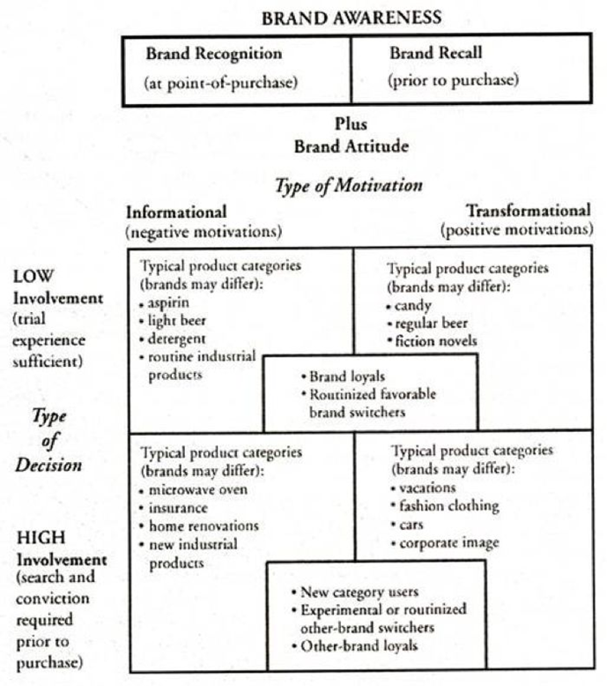

6. Setting the media strategy
The media strategy must be consistent with the decided message where it is drawn directly from the communication objectives (Percy and Rosenbaum-Elliott, 2009).
The timing of the campaign, while the Art Fund was at a healthy position, meant the focus could be initiating a new media mix (Smith, 2018). Targeting students as part of the segmentation as well as a broader audience in general, there were some issues to conquer; it is known that university students are skeptical consumers, thus a difficult market to target (Gilde, 2007), and there are also perceptions that heritage and art are boring, with distance to travel and the cost being the top two reasons that deter young adults from visiting (Eccelesiastical, 2018). However, generally, young people and students are willing to try new products and services (Conveyance Marketing Group, 2020). To attain customers, different media (see Table 3) conveys both informational and transformational strategies (Rossiter-Percy, no date), using both rational and emotional tactics (Smith, 2018), and the mix media marketing provides higher brand awareness and transforms brand attitude (see Table 3).
Lastly, Appendix 1 displays the media used to coincide with the communication objectives.

Table 3: Media Strategy for Art Fund (adapted from Smith, 2018).
Traditional media | Digital media
Print:  - Press and outdoor advertising communicating the effect that art has on consumers (emotional)  - Connecting with consumers (Hill, 2010) | Film advertising:  - Showcasing the benefits of the Art Pass (rational)  - Paid and earned media encouraging e-wom, wom and PR and increasing brand awareness and recognition: shared by V&A, National Portrait gallery, Lonely Planet, Londonist, Gizmodo and Rude Tube (Smith, 2018)  Podcasting:  - Emotional benefits from individual perspectives (emotional and rational)  - Emotional responses (Hill, 2010)  Memes and Tinder Profiles  - Direct marketing to students  - Geographical  - Visual responders (Shifman, 2014)

7. Improvements for the campaign
To conclude, the media strategy and communication strategy are the principal strengths of Art Fund’s campaign where it repositioned the non-profit organisation to appeal to younger and wider audiences, with a strong product where consumers gained a bargain (Smith, 2018). Brand awareness more than doubled, a record number of new Art Pass members were attained with the highest revenue, and 87% higher unique visitor rate on the website (Smith, 2018).
However, segmentation of target audience would have provided more critical insights into understanding consumers (Lawson, 2001). The target market drives all elements of the marketing mix and targeting a more specific audience could have achieved higher brand recognition (Kappel, 2017). With this said, broader targeting matched the limited budget that the Art Fund had for this campaign.

8. References
Artscouncil.org.uk. (2016). Contribution of the arts and culture industry to the UK economy | Arts Council England. [online] Available at: https://www.artscouncil.org.uk/publication/contribution-arts-and-culture-industry-uk-economy-0 [Accessed 02 Apr. 2019].
Binet, L., Field, P. (2018). IPA | The Long and the Short of It: Balancing Short and Long-Term Marketing Strategies. [online] Available at: https://ipa.co.uk/knowledge/publications-reports/the-long-and-the-short-of-it-balancing-short-and-long-term-marketing-strategies [Accessed 01 Apr. 2020].
Brown, M. (2020). Arts bodies threatened with funding cuts over lack of diversity. The Guardian. [online] 18 Feb. Available at: https://www.theguardian.com/culture/2020/feb/18/arts-bodies-threatened-with-funding-cuts-over-lack-of-diversity.
Campbell, C. (2017). The Customer is NOT Always Right? Marketing Orientations in a Dynamic Business World: Proceedings of the 2011 World Marketing Congress. New York: Springer.
Conveyance Marketing Group. (2016). Conveyance Marketing Group. [online] Available at: https://www.conveyancemarketinggroup.com/target-market-analysis-know-your-generation/ [Accessed 01 Apr. 2020].
Department for Digital, Culture, Media & Sport (2012). The Art Fund increases funding to museums and galleries by 50%. [online] GOV.UK. Available at: https://www.gov.uk/government/news/the-art-fund-increases-funding-to-museums-and-galleries-by-50 [Accessed 10 Apr. 2020].
Ecclesiastical (2018) Building a movement for good. [online] Available at: https://www.ecclesiastical.com/documents/annual-report-and-accounts-2018.pdf [Accessed 01 Apr. 2020].
Gilde, C. (2007). Higher education: open for business. Lanham, Md: Lexington Books. P.17.
Hill, D. (2010). About face: the secrets of emotionally effective advertising. London ; Philadelphia: Kogan Page.
Kappel, M. (2017). Find Your Customers with A Target Market Analysis. Forbes. [online] 10 Jan. Available at: https://www.forbes.com/sites/mikekappel/2017/01/09/find-your-customers-with-a-target-market-analysis/#5828162b6bab [Accessed 03 Apr. 2020].
Lantos, G.P. (2010). Consumer Behavior in Action. p.33.
Mason, D., McCarthy, C. (2006). ‘The feeling of exclusion’: Young peoples’ perceptions of art galleries. Museum Management and Curatorship, 21(1), pp.22–29.
Maccalley, R.W. (1996). Marketing channel management : people, products, programs, and markets. Westport, Conn. Praeger. p.214.
Marketing Evolution (2019). Is Broad Reach the Key to Marketing ROI? – Part 2. [online] Marketingevolution.com. Available at: https://www.marketingevolution.com/knowledge-center/is-broad-reach-the-key-to-marketing-roi-part-2 [Accessed 01 Apr. 2020].
Martinez-Ruiz, M.P., Gómez Suárez, M., Isabel Jimenez-Zarco, A. and Izquierdo Yusta, A. (2018). Editorial: From Consumer Experience to Affective Loyalty: Challenges and Prospects in the Psychology of Consumer Behavior
Moore, M., Moore, R.S. (2014). Developments in Marketing Science: Proceedings of the 2001 Academy of Marketing Science (Ams) Annual Conference. Cham ; New York: Springer Verlag.
Porter, M. (2008) Harvard Business Press: Business and Economics. P.59.
Percy, L. and Rosenbaum-Elliott, R. (2009). Strategic advertising management. Oxford, United Kingdom Oxford University Press Oxford, United Kingdom Oxford University Press.
Percy, L., Rosenbaum-Elliott, R. (2011). Strategic brand management. S.L.: Oxford Univ Press.
Rossiter, J.R., Percy, L. and Lars Bergkvist (2018). Marketing Communications: objectives, strategy, tactics. London: Sage Publications Ltd.
Shifman, L. (2014). Memes. Cambridge, Massachusetts The Mit Press.
Smilansky, S. (2018). Experiential marketing: a practical guide to interactive brand experiences. London: Kogan Page.
Smith, J. (2018). National Art Pass: The art of effectiveness | WARC. [online] Available at: https://www.warc.com/content/paywall/article/National_Art_Pass_The_art_of_effectiveness/122402 [Accessed 03 Apr. 2020].
Timson, E. (2019). You Are Not Your Target Audience. [online] Business 2 Community. Available at: https://www.business2community.com/marketing/you-are-not-your-target-audience-02202418Page 87 - Marketing Communications Classics: An International Collection of Classic ... By Maureen Fitzgerald, David Arnott
Todd, S. and Lawson, R. (2001). Lifestyle segmentation and museum/gallery visiting behaviour. International Journal of Nonprofit and Voluntary Sector Marketing, [online] 6(3), pp.269–277. Available at: http://onlinelibrary.wiley.com/doi/10.1002/nvsm.152/abstract.

10. Appendices

10.1 Appendix 1: Decider participant grid with communication objectives of the art fund (adapted from Percy and Rosenbaum-Elliott, 2009).
Role in Decision | Communication Objective | Art Fund objectives and tactics
Initiator | Brand awareness, initial brand attitude | - Change the perceptions of the initial brand attitude and brand awareness of Art Fund and its beneficiaries and partners  - Market penetration  - targeting students  - New product awareness  - Recruit new National Art Pass members  - Build emotional connection among those who want to enjoy art
Influencer | Brand attitude | - Release film showing filmmaker trying to see all the art in London in one day
Decider | Brand attitude and brand purchase intention | - Present art-going as accessible and inviting
Purchaser | Brand purchase intention | - As a gift and art lovers. Art students and students with love of art
User | Brand attitude | - Converting over 10% of trialists to full members in the autumn each year with money saving benefits  - Repeat purchasers

