MTK 718 Social Media Theory

A critical appraisal of the value of social media marketing in retention of the customers and/or users.
Word Count: 5,498

Table of Contents
1. Appraisal of the value and significance of social influencers in relation to the retention of users and customers 3
1.1 Definition and background of social influencers 3
1.1.1 Introduction to the value and significance of social influencers 4
1.2 The value and significance of social influencers 6
1.2.1 Uses and gratifications theory in relation to the value and significance of social influencers 6
1.2.2 The importance of influencer engagement 9
1.3 Cross-selling and upselling 9
1.3.1 Cross-Selling 9
1.3.2 Upselling 11
1.4 The challenges of social influencers and overcoming them 12
1.4.1 Conclusion 13
2. The role and impact of social media marketing as part of the wider marketing function. 16
2.1 Introduction: Definition and origins of Social Media 16
2.2 Background of social media marketing 17
2.3 Case Study: Canon 18
2.3.1 Strategy 18
2.3.2 Structure, style and system 19
2.3.3 Staff and skills 21
2.3.4 Shared Values 22
2.4 Social Media Risk Management 22
2.5 Conclusion 23
3. Possible future trends facing social media marketing in the next 3 – 5 years 24
3.1 Conclusion 26
4. References 27
5. Appendices 36
5.1 Appendix 1: The power of social media influencers (Adglow) 36
5.2 Appendix 2: Loyalty: Seven steps to heaven (CEO Millionaires) 37

Appraisal of the value and significance of social influencers in relation to the retention of users and customers
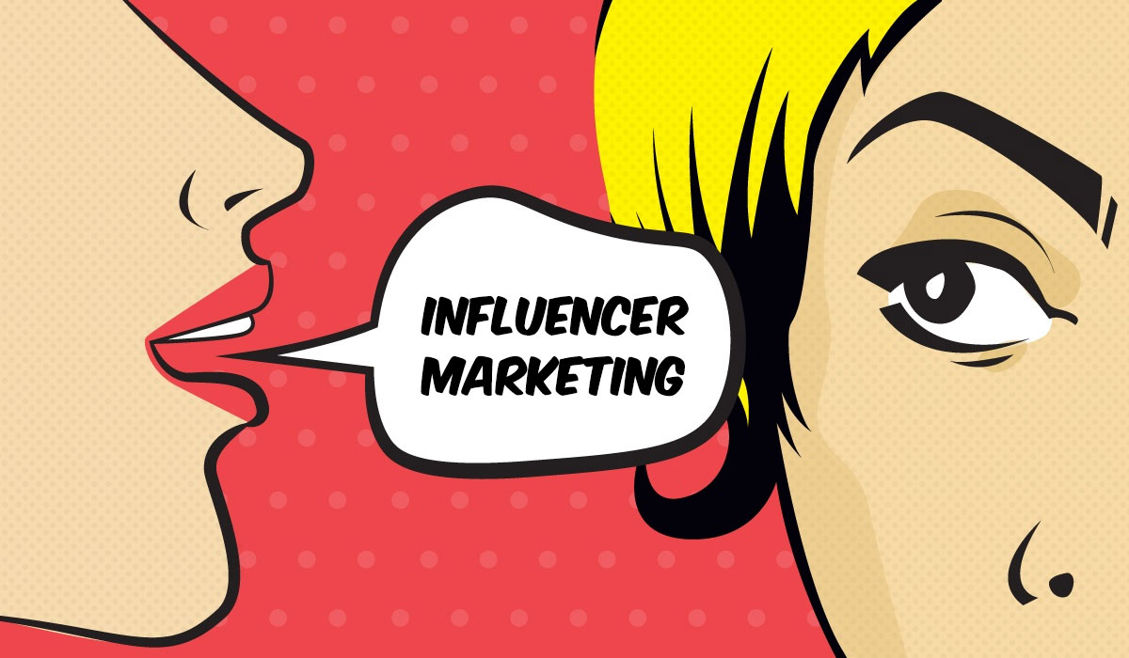
Image: Owl Metrics
The value and significance of social influencers will be appraised alongside the Users and Gratifications Theory (Blumler and Katz, no date) and the concept of up-selling and cross-selling with appropriate data and research for justifications.

Definition and background of social influencers
Social influencers are one party of a three-way relationship based on trust (Radcliffe, 2019), and can be defined as an individual who can affect purchase decisions and has “above-average reach or impact through word-of-mouth or social marketing.” (Greenwood, 2019). Marketers turn to influencers for advertising brands and products (Greenwood, 2019) because influencers are “often highly knowledgeable about a specific subject such as food, fashion, beauty or technology” (Greenwood, 2019). Consumers trust influencers when they promote products that correlates with their continuous focus on one subject which provides the perception of authority (Fastenau, 2018).

Cultural conformity, power and control and personal connections are ingrained in human nature and our instincts (Hoos, 2019). With the rise of social media and online communities, social influencers were inevitable (Tribe, 2020); capitalising on our most natural tendencies, emotions and desires (Hoos, 2019).

There are different types of social influencers for businesses to identify for their brand or campaign (see Appendix 1), from micro influencers to macro, all of which have various properties and utilise different channels and tools (see Figure 1). For example, top tier influencers may be less of a brand match but because of their large following, they can offer wider reach (See Table 1).

1.1.1 Introduction to the value and significance of social influencers
The market size of influencer marketing has grown 3.8X between 2016 and 2019 (see Figure 2), with 36% of global marketers using micro and 30% using macro (see Figure 2). In addition, 63% of marketers intend to increase their influencer marketing budget within the next 12 months (Influencer Marketing Hub, 2020), with 17% of marketers already spending half their marketing budget on influencers (Bailis, 2019). When they are a close brand match, they can have high value and return of investment (ROI); “businesses are making $5.20 for every $1 spent on influencer marketing” (Influencer Marketing Hub, 2020), however this is a strategy that needs to be assessed and planned (see Table 1).

Influencer type |  |  | Properties |  | Potential benefits/ strengths | Potential weaknesses
 | Micro | - Under 100k followers  - Focused and authentic |  | - Since 2018, most popular choice to work with  - Strong brand match – High relevancy  - Audiences are more likely to trust |  |  | - Not a wide reach  - Relies on communities rather than exclusively itself
 | Authoritative | - Experts in the field e.g. journalists, scientists.  - Thought leaders and opinion formers |  | - Audiences trust them because of their knowledge |  |  | - Could be costly  - May not work with brands if the information does not correlate
 | Niche | - Defined by narrow interest area not size of following  - Associated with an industry sector |  | - Audiences trust them  - Small communities are built up |  |  | - Limiting  - Not always a wide reach
 | Mid-Tier | - 100k-1 million followers  - Strong focus on community |  | - Engagement rates usually high |  |  | - Costly  - Difficult to identify
 | Top-Tier | - 1 million followers or more  - Usually a celebrity |  | - Largest reach |  |  | - Lowest engagement rates  - Costly  - Rarely a brand match
Table 1: Influencer types and their properties (adapted from Dahl, 2012).
Moreover, “the demand for influencers is driven by social media’s increased impact on the general population and their buying habits” (Mullan, 2020). In particularly, there is importance for the fashion industry to have a strong social presence on social media channels because 30.4% of shoppers in the UK are using social media as a stimulus for fashion and clothing purchases (Mullan, 2020). However, “75% of marketing and communications professionals say verified web traffic of an influencer is the most important criteria when selecting an influencer” (Influencer Marketing Hub, 2020), and the engagement from influencers has higher value than impressions or the amount of followers they have (Influencer Marketing Hub, 2020), when it comes to the retainment of customers and users. “Engagement is the new impressions. It matters as much, if not more, than someone’s reach.” (Influencer Marketing Hub, 2020).
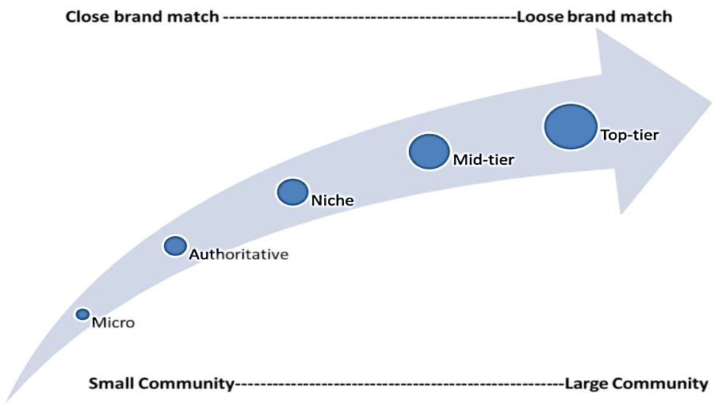

Figure 1: Social influencer typologies

Figure 2: Influencer market size worldwide from 2016 to 2019 (Statista, 2019).

Figure 3: Share of global marketers using influencers as of January 2019. (Statista, 2019).

The value and significance of social influencers
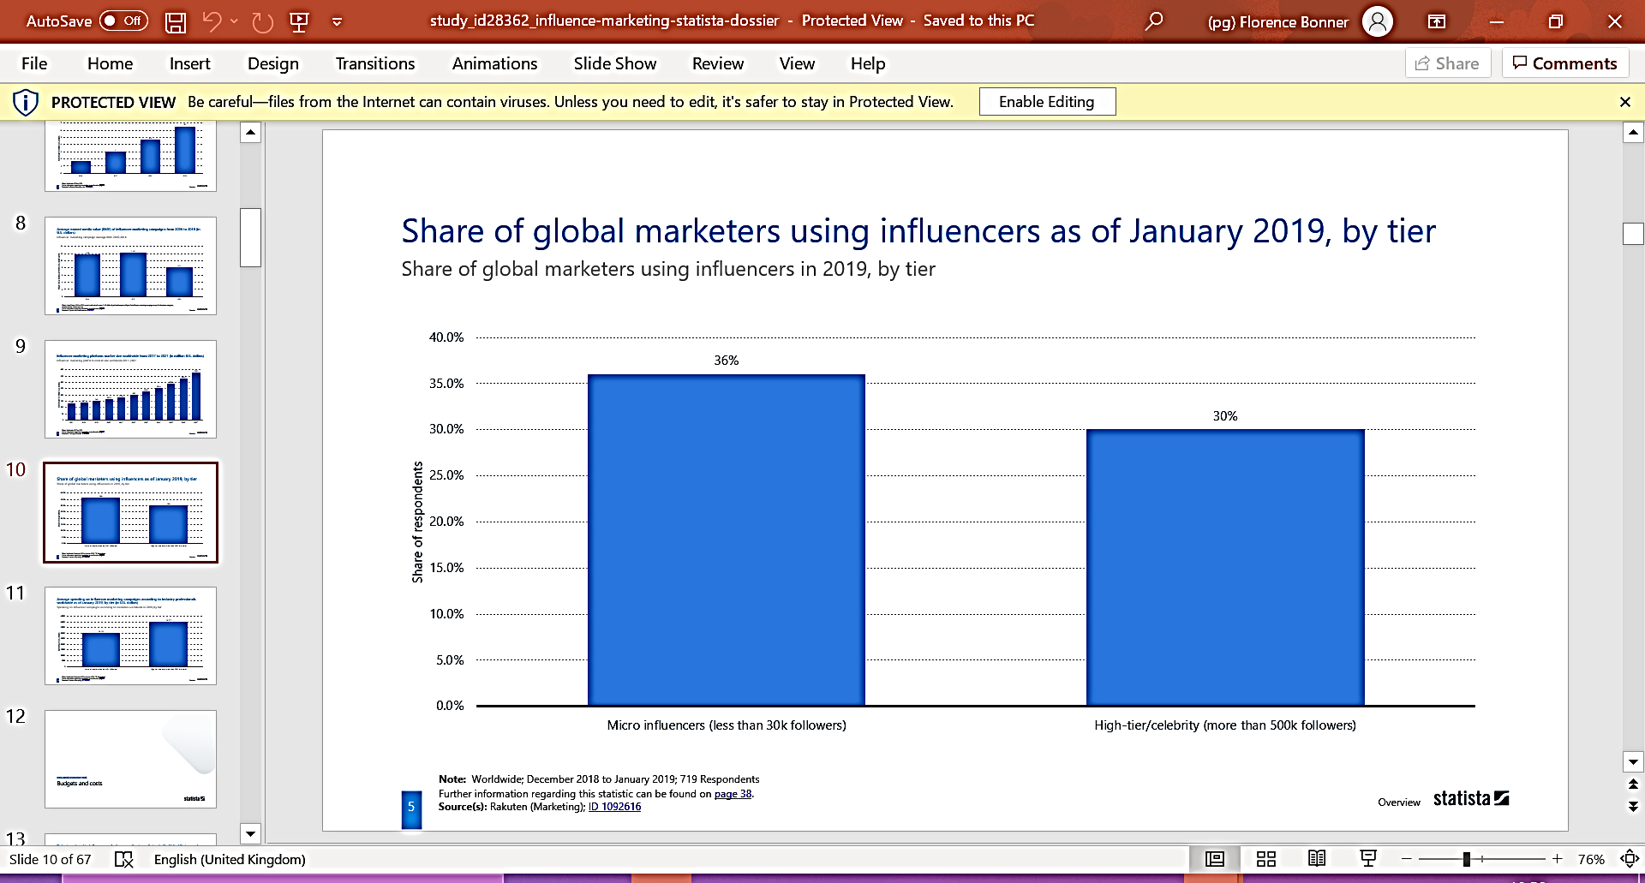
The value of social influencers can be viewed as the level of what influencers can offer and their impact (Blue Fountain Media, 2020). To reduce risks, validity, relevance, brand match and fit with both the influencer’s and brand’s target audience should be evaluated (Hoare-Smith, 2019).

1.2.1 Uses and gratifications theory in relation to the value and significance of social influencers
The Uses and Gratifications theory (UGT) suggests that users sought after entertainment, diversion and information as their motivations for using media (Blumler and Katz, no date).
Brittany Furlan, who originally gained fame from Vine, became the top viewed woman and labelled as one of the most influential people on the internet (Time, 2015). The internet personality who entertains audiences with her content had great value and significance for brands, and her increased value rises her cost; “quick-to-the-punchline sketches or pranks on the unsuspecting public are worth between $7,000 and $20,000 to brands targeting Furlan’s massive audience” (Gilman, 2014). The influencer gained popularity with 9.9m followers, her entertainment (UGT) increased customer retention rates with a loyal fanbase, and therefore she was sought after by brands.
Additionally, brands are collaborating with influencers as brands rather than influencers (Neate, 2019). For example, top-tier Zoella with 11.4m subscribers on YouTube, utilises the diversion concept (Blumler and Katz, no date), with her perceived perfect British life (Shadijanova, 2018). She holds a loyal fanbase and high retention of customers with engaging videos that have a better ROI than other tools (Marka, 2019).
Furthermore, when actions by the user are led by social comparison or social identity, there is the outcome of higher brand awareness (see Figure 4). Correspondingly, online communities can be influencers, creating a buzz, sizzle of the 5s (Chaffey, 2018) and enable co-creation which generates higher engagement (see Figure 5).
There has been a paradigm shift in which customers engage with brands (Dolan et al., 2015), and 93% of professionals believe influencer marketing is effective or building brand awareness, where 85% of users trust content generated by influencers more than content published by the brands (see Appendix 1).

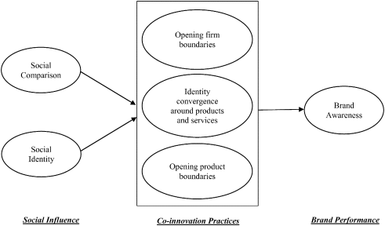

Figure 4: Social Media Engagement Behaviour Typologies (Science Direct, 2019).
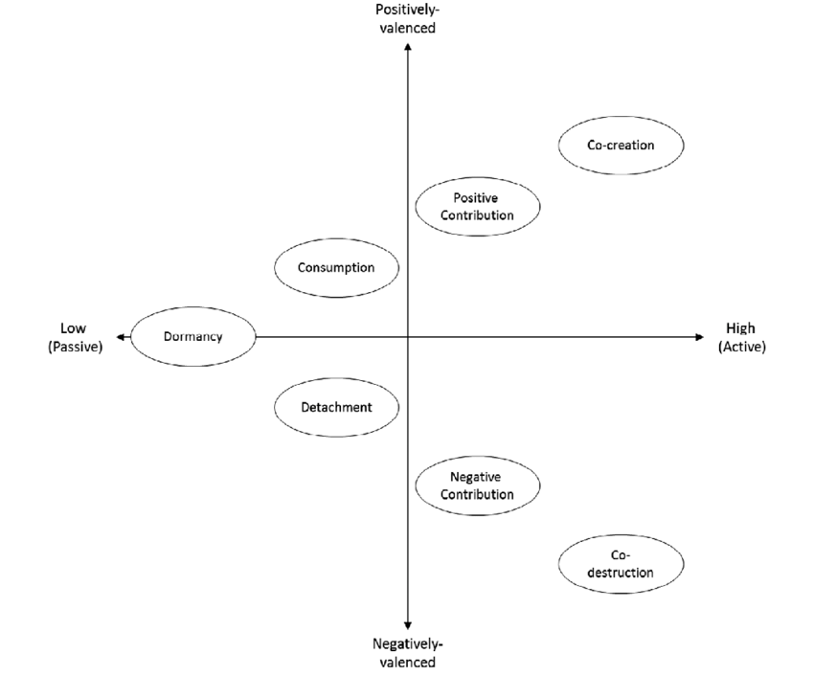
Figure 5: Social theory behind social influencers (Science Direct, 2019).
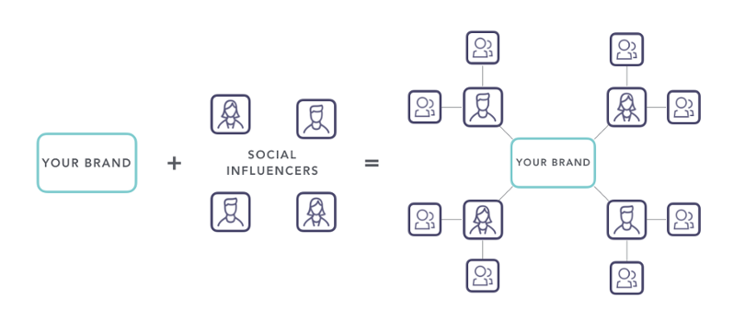
Figure 6: Social influencer business model (Fastenau, 2018).

1.2.2 The importance of influencer engagement
Customer engagement, which encourages loyalty and advocacy, can be defined as "repeated interactions that strengthen the emotional, psychological or physical investment a customer has in a brand” (Chaffey).
Engagement is a valuable metric to analyse the potential retention of customers (Hollebeek and Sprott, 2019), transforming suspects to raving fans with repeat purchases (see Appendix 2). It is also the most-used metric to measure the value and significance of social influencers (Barker, 2019), as influencers come at a price, which vary depending on industry and influencer type.
Debatably, “the modern ideas of celebrity, brands, marketing, the way we think about influence, was all invented by Paris Hilton [top-tier and celebrity]” (The American Meme, 2019). Hilton incorporates her fans on social channels responding, co-creating and engaging with user-generated content. Hilton has great value and significance in the retention of customers with 3% engagement rate (Social Blade, 2020), where Instagram engagement rates at an all-time low (Williams, 2019).
Nevertheless, social influencers can be of very high value. For example, Gymshark, an ecommerce fitness business, grew to a £100m business in 7 years, with influencer marketing being the biggest ROI (Tayla, 2019). Gymshark created more brand awareness with an online community (Blumler and Katz, no date) and celebrates 200X growth, and 11% engagement rate (Lavendaire, 2019). Figure 6 displays the model that Gymshark adopted and achieved over 1.2 million customers and a loyal fanbase utilising influencer marketing (Bearne, 2018).
Also, social influencers can be ordinary people with some sort of influence on their friends and social groups. These are known by marketers as nano influencers (Godwin, 2018). It is considered that brand communities, customers and staff are more influential than paid-for influencers (Edelman, no date), and this could be because their engagement rates are higher. While the individual reach may be small, communities are capable of a wider reach, and they are more accessible because they can be free, and cheaper to use (Godwin, 2018).

Cross-selling and upselling
Additional marketing objectives that are useful for social influencers to utilise with pull marketing and persuasive marketing is both cross-selling and up-selling; “cross-selling and upselling are two distinct practices that involve approaching existing customers and convincing them to purchase additional products or services” (Salesforce, 2019).

1.3.1 Cross-Selling
Firstly, cross-selling can have a positive impact, “increasing customer loyalty and deepening customer relationships which in turn can improve customer lifetime value and retention” (Salesforce, 2019). Furthermore, “the main benefits of cross-selling include increased sales revenue, improve customer satisfaction and in B2B businesses, increased Customer Lifetime Value (Salesforce, 2019). Influencers can assist with cross-selling when the influencer marketing strategy is a partnership or long-term relationship (Rowe, 2020). For example, through persuasion marketing, influencers advertise products that can be bought together (see Figure 7). This example demonstrates an incentive to persuade customers to purchase more than one product; it is “human behaviour that we all want to get a good deal” (Sales Force, 2019). Influencers also can have personalised discounts, promo codes that customers can use, and this gives the perception that they are benefiting from purchasing through the influencer. It is also an excellent way of tracking the attainment and retainment of customers.

Figure 7: Instagram post displaying cross-selling (Everyday Abby, 2020).
Additionally, Figure 8 displays Apple’s influencer marketing campaign cross-selling Air Pods which targets existing customers but aims to increase sales volume for each customer and increase lifetime value. This broadens the scope of the relationship with the customer and increasing customer retention (Kamakura, 2008). It can be argued that Apple went from mockery to millennial status with this strategy, where millennials are harder to reach through traditional advertising but respond well to social influencers (Cresci, 2019).
While this can be successful for the retention of customers and brings value and significance for brands, it can be argued that cross-selling is a profit-losing strategy (Harvard Business Review, 2012). With influencer marketing being costly, cross-selling can generate marketing expenses where the extension of undesirable behaviour is placed on a greater number of products and services (Shah and Kumar, 2012). Therefore, to retain customers when using social influencers to cross-sell products, the correct target audience should be chosen, and the influencer should have a strong brand match (Davila, 2019).
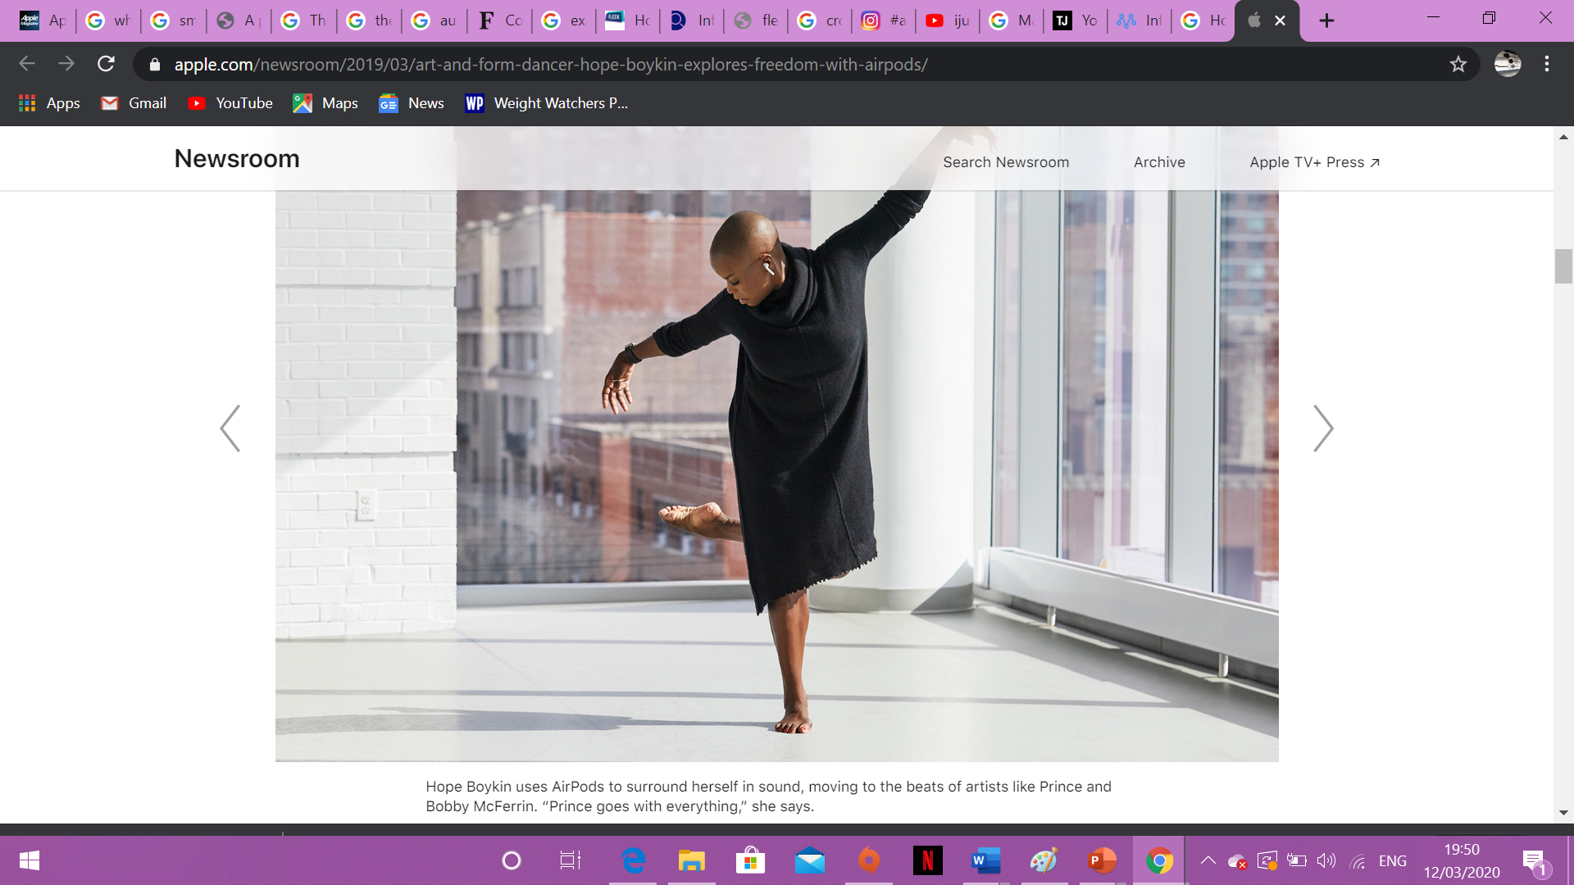
Figure 8: Apple’s cross-selling tactic of their Air Pods to existing Apple customers using social influencers (Apple, 2019).

1.3.2 Upselling
Upselling can be more effective for brands to use than cross-selling (see Figure 9) with supplying customers with valuable information (Chipman 2019) and offering a perceivably better product. For example, Figure 10 displays technological and gaming influencer, iJustine upselling a Samsung phone. Customers sub-consciously feel inclined to purchase a more expensive and up-to-date product because someone knowledgeable and influential recommends it (Grin, 2019).

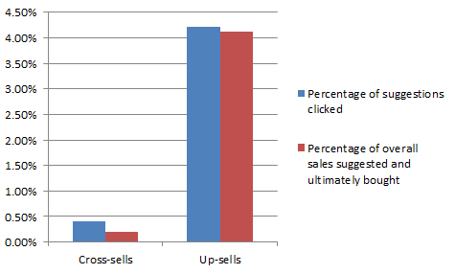

Figure 9: Comparing the cross-selling and up-selling suggestions click through rates through to conversions (Patel, 2019).

Figure 10: Example of social influencer up-selling (iJustine, 2020).

1.4 The challenges of social influencers and overcoming them
Although it is possible for social influencers to have high value and significance in the retention of customers, there are also challenges.
Firstly, brands primarily employ influencers for brand awareness and the acquisition and attainment of new customers, rather than retention (see Figure 11). Engagement is the most common metric used for measuring influencer marketing success (Bailis, 2019), because an influencer may have a wide reach with a combination of ‘fake followers’, and the retention of their customers may not be high (see Figure 12). 61% of marketers agree that it is challenging to find the best influencers for a campaign, suggesting this problem is far from solved (Bailis, 2019).
Another challenge is consumers doubt the validity of influencers selling products and being involved with paid advertisements. For example, consumers may have the perception that influencers may be selling a product merely for money and not for the product benefit (see Figure 13). 86% of US customers distrust influencers, with boomers and Gen X being the age groups with the lowest trust (see Figure 14). In the UK, 96% of consumers do not trust influencers (YouGov, 2019), and this means the strategy can become obsolete.
With the rise of both sceptical and informed consumers, micro influencers seem to have more value and significance for brands, with 60% higher engagement and a projection that they are more genuine when promoting products and brands, and therefore customers are more likely to be loyal to the influencer and brand (Pierucci, 2018), enabling a higher ROI.
Additionally, there is a paradigm shift in attitudes towards social influencers. While credibility of the influencer and then through electronic word-of-mouth (e-WOM) can be compromised by the disclosure of paid posts and advertisements, (Audrezet and Charry, 2019), consumers seem to be more accustomed to seeing posts listed as a paid ad, and it no longer has the negative effect with repeat purchase in the purchase decision (see Figure 15).

1.4.1 Conclusion
To conclude, it can be estimated that increasing retention by 5% can increase profits by 25-95% (Marka, 2019), and while social influencers can have a large reach, an excellent way of penetrating online communities, and they are the most popular tool and tactic for reach and brand awareness (Fastenau, 2018), they are not always effective in the retention of customers. Influencers are becoming more prevalent which in turn makes it more difficult for every influencer to cut through the noise in the marketplace with brands all screaming for attention (Grin, 2019). However, it seems that if influencers focus on one area of knowledge or interest, most likely being niche, and a lower following from mid-tier downwards, they will gain a more loyal fanbase, and in turn giving the strategy value and significance with a higher retention of customers.
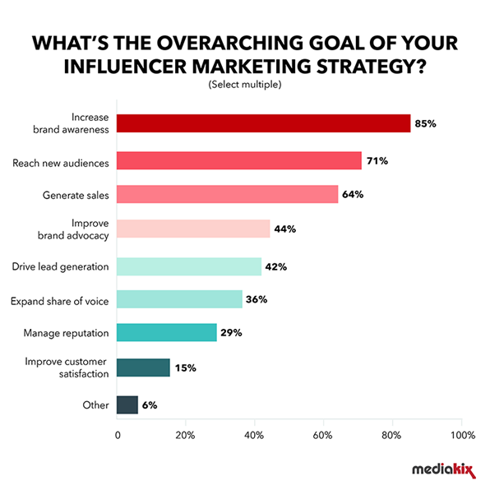

Figure 11: Most popular goals for marketers using influencer marketing (Bailis, 2020).

Figure 12: Leading Challenges of influencer marketing in the US (Statista, 2020).

Figure 13: Example of consumer distrust in influencers paid ads (Watson, 2019).
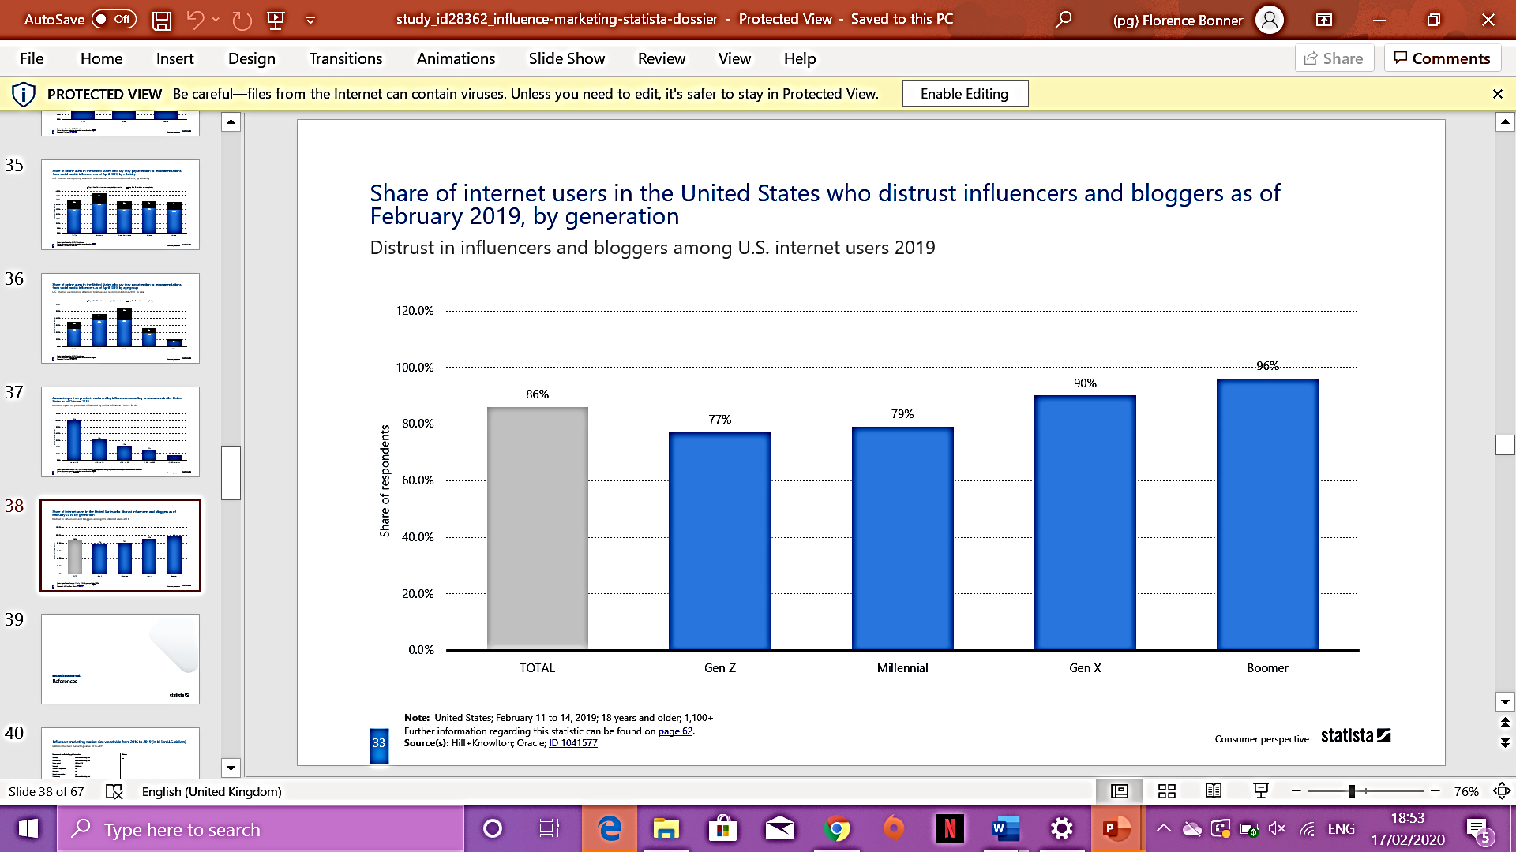
Figure 14: Share of internet users in the US who distrust influencers and bloggers (Statista, 2019).
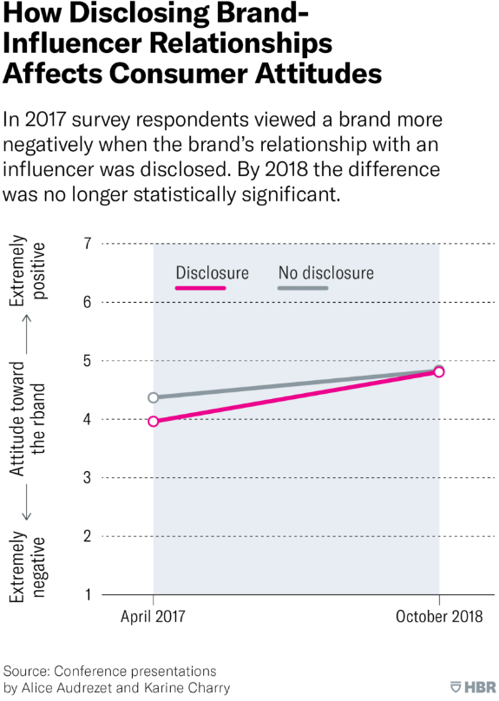

Figure 15: How disclosing brand-influencer relationships affects consumer attitudes (Audrezet and Charry, 2019).

The role and impact of social media marketing as part of the wider marketing function.

Image: Pexels

Within this appraisal, the role and impact of social media as part of the wider marketing function will be assessed using Canon’s case study and the application of Mckinsey’s 7S’s for the internal impact, and Risk Management for the external impact.

2.1 Introduction: Definition and origins of Social Media
Social media can be viewed as online channels incorporating digital tools such as blogs, microblogs, social networking sites, media sharing sites, social bookmarking and voting sites, forums, reviews, chat rooms and virtual worlds (Zarrella, 2020). Additionally, it can refer to the sites and services that emerged during the early 2000s that provide tools for users to create and share content (Boyd, 2014).
There are debates surrounding around the innovation of social media, with some arguing that social media has been around since the late 1970’s through PLATO’s System, a pre-internet online platform (Smith, 2017), with the innovation of an early forum that allowed users to leave notes for each other; the Talkomatic (L’onje, 2020), which could be viewed as the first ever chatroom. Others believe the mid 1990’s featured the first social media that we recognise today (see Figure 16). Either way, social media has had an explosive growth over the last 12 years (Banner, 2019), with over 3.5 billion social media users worldwide (Kemp, 2020), over 3 times as much since 2010 (Statista, 2019), with 3.2 billion of those consuming as mobile users (see Figure 17).
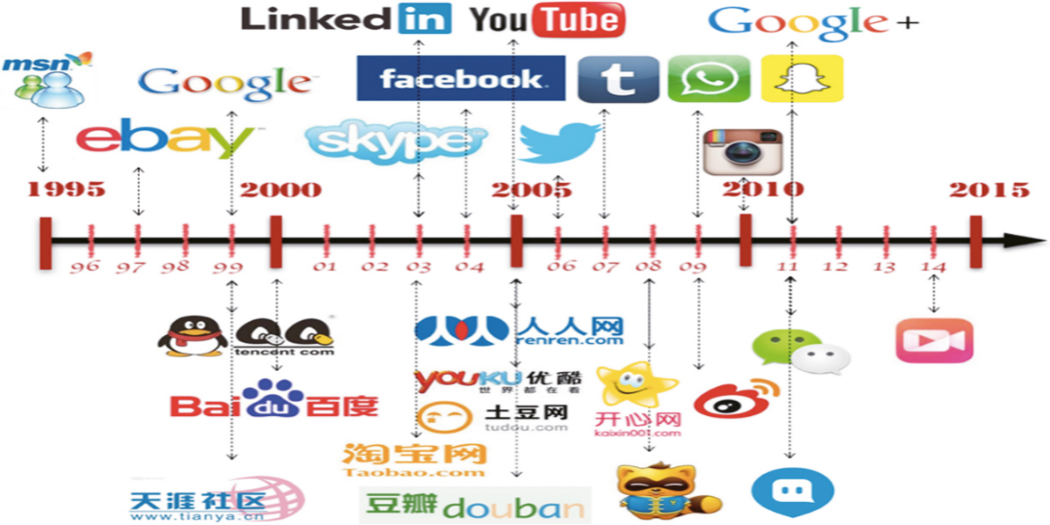

Figure 16: Social Media Timeline: platforms (Alamri, 2017).
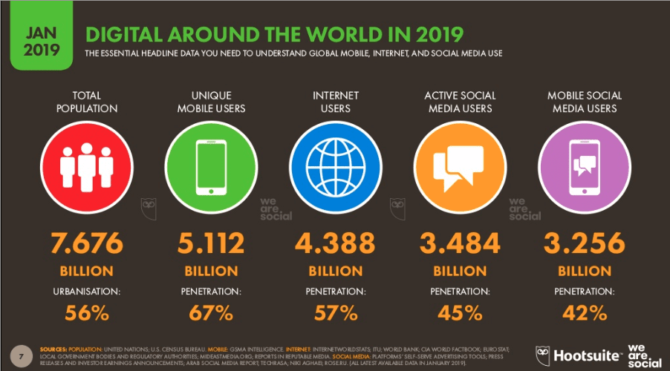

Figure 17: International digital usage (Chaffey, 2019).

2.2 Background of social media marketing
Marketing is defined in the dictionary as “the action or business of promoting and selling products or services, including market research and advertising” (OED, 2020). It can also be defined as the “management process responsible for identifying, anticipating and satisfying customer requirements profitably” (Chartered Institute of Marketing, no date). Evolvingly, with ecommerce and when digital marketing, and web 2.0 sites emerged so did the recognition of content marketing and the potential of social media to facilitate marketing (King, 2019). Social networking sites started to incorporate marketing and therefore, the infrastructures of those very sites started to adapt and modify (Gáti, 2012). It can be viewed that we are entering the era of social shopping (Arnold, 2018), with the line between social media and e-commerce beginning to disappear.
Digital marketing has brought a seismic shift in ways to approach customers and how to target them (Digital Marketing Institute, 2020), and gives opportunities for personalisation, direct marketing and targeting, customer relationship management, wider reach, easier analysis of metrics, and can leverage traditional marketing (Chaffey et al., 2019).
Arguably, “social media is not a magic tonic to solve marketing problems but one piece of a well-planned and executed inbound marketing strategy that is tightly aligned to business objectives” (Bodnar et al., 2011).

2.3 Case Study: Canon
Camera company Canon implemented a social campaign focusing on user generated content and social media influencers to drive sales and help local businesses in Scandinavia (Poulsen and Marcel, 2019).
The decline of camera purchases due to social media and smart phones pushed Canon to launch a compact ‘mirrorless’ camera. The brand wanted to encourage Nordic consumers to use both cameras and social media to support local businesses; as smartphones still do not hold the same quality and aesthetic appeal as camera’s do (Poulsen and Marcel, 2019). This was to challenge the perceptions that phone cameras are good enough to do that job. The campaign stimulated people to take high quality photos of local businesses and post them to Google Maps to give business more reach and awareness. Successfully, 22,000 people participated, and the perceptions of cameras improved into a more mainstream social media age, sales of Canon cameras increased, and Canon went from 6% to 14% in market share in the ‘mirrorless’ category (Poulsen and Marcel, 2019).
Canon maintains its global position with social media, and country-specific content marketing is always used for their campaigns with over 1.5m likes across their various Facebook pages (Lee, 2016).
With their local approach, they engage customers with customer relationship management and replying to their customers on social media (Lee, 2016), which leverages e-wom and wom.
“We have a local presence on social media platforms across EMEA to engage with and inspire our photography and business communities” (Canon, 2020).

2.3.1 Strategy
The strategy to implement such a successful social media campaign was a penetration and product attractiveness strategy. With people substituting cameras for smartphones and their built-in cameras, Canon had to find an innovative way of putting cameras back on the market again (Poulsen and Marcel, 2019).
The target audience of 'Adventurous Achievers' was selected; younger audience (aged 16-34), typically living in the Nordic urban cities who like to explore their local areas and are interested in buying the best products they can afford. Influencers and photographers were also segmented within the target audience.
This content-driven, localised campaign encouraged the target audience to actively use Google Maps to promote the “power of photography” (Poulsen and Marcel, 2019), and the quality of the Canon EOS M5, also highlighting the difference in taking photos with a smartphone and on a camera that has the ability of lights, angles and lines. The social media campaign “makes you want to be more active and discover these hidden aspects of your life” (Canon, 2020). This was done by young people using the camera, vising local spots where they could highlight the beauty and engage users when they uploaded it onto Google Maps and on Google’s Local Guides platform. The strategy was the first of its kind to use social media this way and partner with Google utilising user-generated content (Poulsen and Marcel, 2019).
Nikon, Canon’s leading and direct competitor also now positions their brand as the ‘everyday photography’ to be more appropriate within our digital age (Nikon, 2020), with their mission to give a sense of community to its existing customers with the sense of belonging (Nikon, 2020). This lengthens their customer lifetime value (Edel, 2017). This is contrasting to Canon that aims for consumers to adventure and focuses on acquisition rather than primarily retention. However, co-creation is part of both brand’s strategies.

Structure, style and system
The structure and style aspects here depict how the company is organised, who reports to who, leaderships and how the departments are managed. The system indicates the technology used internally to complete daily tasks (Mind Tools, 2020).
Canon dedicates a team solely to Canon cameras and equipment, and a separate team to promote content and find suitable businesses to work with (Hatch, 2019). It is proved that dividing workload throughout the workplace to relieve individual staff members is effective in increasing work productivity (Sloan, 2018). The Japanese international corporation has three principal segments to their business; Office Business Unit, Consumer Business Unit and the Industry Business Unit, and this aids the strategy of strengthening the financial structure (Canon Annual Report, 2018). There are departments for Marketing and PR, Sales and consulting, IT and business solutions, and business admin and operations. Moreover, their digital marketing is separate to their traditional marketing which can be positive in terms of lifting workload and identifying, anticipating and satisfying customer needs to achieve profit (Chaffey et al., 2019), however, combining core aspects of digital marketing with traditional to focus on customer needs rather than channels is the most profitable” (Woods, 2019).
The Board of Directors hold the authoritative position within the infrastructure who must have “integrity and a high sense of morality and must faithfully perform their duties for the Company” (Code of Business Code and Ethics, 2020). See Figures 19 and 20 for the complete infrastructure of Canon.
Canon’s style and structure enables the brand to employ social media marketing strategies, such as the EOS M5 campaign, that cultivates brand awareness and sustains its brand positioning (Digital Marketing Institute, 2020). With a smartphone generation (Tan, 2017), Canon achieves storytelling and content marketing through social channels to appeal to millennials (Tan, 2017). Canon had to change from a product-centric business to a consumer-centric one, and to co-exist with smartphones, the structure must communicate and work intrinsically to sustain competitive advantage (Tan, 2017). The various teams within Canon came up with influencers, content marketing, and E-CRM (Poulsen and Marcel, 2019). This was so focussed, that Canon employed Canon’s Influencer Marketing Programs, as well as Brand education programs to stay advanced (Canon, 2020).
From internal to consumers, “Canon's users advocate for the brand on social media because the platform is a visual medium that inspires, connects and creates opportunities for people to express themselves” (Lim, 2018), and this correlation can be positive to sell when both internal and external audiences share the same goals, satisfying both customer and staff needs (Kidd, 2018).
For information sharing within the company, keeping in compliance with GDPR and Data protection (Canon, 2020), the company intranet is used to release information internally for regulations and brand management. However, it seems there are missed opportunities for internal social media platforms within Canon. Internal social media strategies can boost morale (EHS, 2020) and team build even when employees are working remotely (Gotter, 2020). It is estimated that 60% of employees, globally, feel less-than-enthusiastic about internal communications because few businesses are investing in newer technologies like internal social media (Gotter, 2020). Furthermore, 55% of employees globally report wanting more digital and social engagement from employees (SGEi, 2020). Companies like Grant Thorton, a consultancy firm, revolutionised their internal communication techniques by social media which resulted in 59% of employees feeling more connected to one another and 67% feel more connected to the business (SGEi, 2020).
Figure 19: Corporate organisation (Canon, 2020).
Figure 20: Corporate organisation (Canon, 2020).

2.3.3 Staff and skills
The selection of staff and their skills is important for business operations and success (Lowry and Glenn, 2007). Digital marketing and social media are hard to grasp with social media requiring a lot of content to be created quickly (Public Relations Sydney, 2020). Due to a quick transition of strategy, which surrounded around social media to work with the rest of the marketing objectives, training programs had to be able to leverage this (Canon, 2020).
Furthermore, flexible work styles within Canon help them to prevent micromanagement (Atamaniuk, 2019). This is beneficial for businesses that are or transitioning into a social media business, where a more diverse, flexible workforce attracts and retains the skills needed for social media campaigns (NI Business, 2020).
However, there is a digital skills gap that is a global issue, with governments trying to become a digital organisation themselves (Canon, 2020), and this gap is widening fast (Milano, 2019). Currently, there is “failure to satisfy the digital growth area, and it is placing significant pressure on HR professionals across the continent. However, it is also threatening to slow the progress being forged by digital transformation among European businesses; and this would be very destructive to overall growth” (Canon, 2020). Recently, social media and digital tools are an aspect that is yet to be fully grasped by the company, with job listings and training facilities to develop a more digital mindset (Canon, 2020).
Additionally, with Canon’s ever-growing influencer marketing program, small team and lack of digital and social media skills, the organisation outhouses the data analytics and influencer campaigns because they need such a big team, and agencies bring expertise and connections (Ilyse, 2018).
However, Canon also have sub teams of CRM and data analytics, content and campaign team and others (Jackson, 2019), and this provides staff the ability to use their skills and make decisions without needing managerial approval (Quain, 2019). 42% of employees working in teams of less than 10 were engaged at work, with only 30% of employees in larger teams (Morgan, 2015). Canon have avoided the Ringelmann Effect, the tendency for individual members to become less productive as the size of a group increases (Schneider, 2016), where their teams can be self-sufficient and motivated (Canon, 2020).

2.3.4 Shared Values
Corporate Shared Value is a new generation business thinking which enhances the competitive position of the company while at the same time advances the society in which it operates (Folk, 2018).
Canon respects the diversity of employees and aims to create workplaces in which employees can express their individuality and work with a sense of worth and achievement, with human resource development systems and human rights policies that assist minority groups (Canon, 2020). This has been shown to provide a more profitable business when the workforce is satisfied (Liffreing, 2018).
However, 55% approve of CEO (Glass Door, 2020). Percentages of 67% and higher, have better financial outcomes with a more satisfied workplace that sustain core values (Barnes, 2019).

2.4 Social Media Risk Management
It can be argued that “social media has grown popularity and importance faster than most companies’ risk management capabilities can currently handle (Culp, 2014). There are risks when using social media to implement a strategy and as a channel for marketing and business with its many platform; security, privacy and brand image are but a few (Accenture, 2014). There are also issues of trading, price fluctuations, loss of sales, and procurement (Johnson et al., 2017), and both internal and external impacts need management to reduce risks.
Canon’s approach is to recognise improvement and implementation of risk management systems to deal with risks (Canon, 2020). It is crucial for Canon to ensure proper operation and to continually improve corporate value in terms of CRM and E-CRM (Canon, 2020), where 80% of consumers expect companies to respond within 24 hours when social media is implemented in the strategy (Hutchinson, 2017). Canon pushes the notion that they are a “company meriting social value” (Canon, 2020), which should include the appropriate PR operations and customer relationship management to protect the brand and its customers. Developing internal rules, policy objectives and education to all employees is paramount to communicating and solving potential challenges, thus reducing risk (Khoros, 2020).
Canon’s training programs also reduces risks of skills gaps and sustains competitive advantage (Canon, 2020).

2.5 Conclusion
In conclusion, Canon used a penetration strategy to ignite the want to use good quality cameras and not just cameras that are built in smart phone, and with social media they were able to reposition their brand and maintain market leaders. Social media has enabled direct marketing that increases engagement and retention of customers with content marketing, influencer marketing, while ensuring their brand identify of community-based values (Liffreing, 2018). Social media has also enabled the reach of new audiences (Canon, 2020).
However, there are problems with social media; from data protection, privacy and security to measuring effectiveness of tools and metrics (Dahl, 2015). Additionally, skills gaps across all industries are expected to grow in the ‘Fourth Industrial Revolution’ (Milano, 2019). Rapid advances in artificial intelligence (AI), robotics and other emerging technologies are rapid which where skills and jobs need to be adapted (Milano, 2019). 133 million new roles will be generated due to this, and Canon must use their risk management calculating external and internal factors that could damage the brand’s innovation and success while also sustaining innovation (Beers, 2020). Thus, Canon needs to increase and sustain their training programmes and implement the use of internal social media to enable better communication. Furthermore, internal social media also assists the E-CRM; increasing lifetime value and decreasing risks of negative PR if anything did go wrong in the strategy in the future (DiScipio, 2017). However, this is also an external, universal problem and governments around the world need to assist in digital training to keep up with a digitally advancing world.

Possible future trends facing social media marketing in the next 3 – 5 years
Image: Pexels
This section of the appraisal will discuss significant future trends of social media; video and interactive content regarding the ‘Goldfish Effect’, and influencer marketing with AI using relevant research and data. Issues such as GDPR and cyber security will also be discussed.
With already over 2.5bn social network users worldwide (Statista, 2017), with a global penetration rate of 71% (Statista, 2020), the significant continuing growth of social media is unquestionable, and important for consumers and businesses to keep up with. Moreover, the uses of social media shift over time; 40% of users practice social media to stay in touch with friends, 37% find funny or entertaining content and 33% to share photos or videos with others (Statista, 2019). While social media is incorporating more business, ecommerce and financial tools such as the Facebook e-shop, and the upcoming Libra currency, research and find products is only 30% of the reasons people use social media (Statista, 2020). This is challenging for businesses wanting to utilise social media marketing. To assist business strategies, “it is important to understand why brand communities form online, what motivates participation and how, for example brand communities are different on various channels” (Dahl, 2015).
Firstly, videos are increasingly popular with social media; they are already the most popular media by far, along with word of mouth, social influencers and content marketing (WARC, 2019). Where it used to be text heavy, social media incorporates more of the content mix. This is because humans process images 60,000 X faster than text (Pant, 2015), and visual content corresponds to our short attention spans (Litsa, 2016). By the analysis of view-through rate metrics, it has been discovered that the average user will only spend 10 seconds watching a video before they lose interest (Patel, 2017). This correlates with the ‘Goldfish Effect’, where the use of social media and mobile internet could be the reason for the continuous shortening of attention spans (McPadden, 2015). Thus, brands are resorting to shortening their videos, and social networking apps such as TikTok, and tools on Instagram, like stories, are limiting content to 10-12 seconds. New generations and social media users are now expecting instantaneous media and instant gratification (Patel, 2014), where they can quickly pick up their device, be entertained, without delay, and then move on to the next post or app. The future of social media sees digital platforms with less text, and more short videos (Wyzowl, 2020). Not only is it because of attention spans but because video is also gaining more interest than photos (Wyzowl, 2020). For example, on Twitter videos are 6 X more likely to be retweeted than photos (Wyzowl, 2020), with other platforms such as Facebook’s sharing culture of videos, and Instagram’s IGTV. Additionally, these short videos are essentially no cost to organisations to employ (Safko, 2012).
Moreover, within the content mix, and content marketing ruling the online space (Patel, 2020), interactive content is becoming increasingly popular with C2C, B2C and B2B (Bodnar and Cohen, 2012). 79% of marketers say that interactive content can increase retention of customers (Williams, 2018), and it is the best tool to engage a target audience (Patel, 2020). This can include videos, widgets on web 2.0 and VR systems.
Furthermore, social influencers are being used within marketing more frequently, already growing to a $5-10b industry (Bailis, 2020), with massive growth expected in the next 5 years (The Social Intelligence Lab, 2020), regardless of their debatable role and impact or increasing informed and cynical consumers that question the integrity and validity. However, as technology advances, with the growth of AI and machine learning, the rise of the virtual, artificial, computer-generated influencer has begun (Hsu, 2019). For example, virtual influencer, Lil Miquela, who takes the role of Instagram personality, YouTube blogger, and singer, is now worth $125 million. Additionally, ‘she’ has been involved in a Calvin Klein campaign with famous model, Bella Hadid, where it showed reality and virtual reality worlds colliding (Kulp, 2019).
Social media is a space for both creation and business (Ketelaars, 2011); “some [virtual influencers] have been created as art projects, drawing attention to the absurdities of social media. Others appear to be PR stunts” (Graham, 2019). Agencies are experimenting with virtual micro-influencers, drama and storytelling campaigns, and invading the real world with marketing (Sokolov, 2019).
This astonishing future trend (Kolsquare, 2020) is significant for brands to gain competitive advantage as virtual influencers, while niche, are expected to grow enormously (Hsu, 2019). Also, brands will save money while having complete autonomy on brand image and marketing; “a virtual influencer provides affordable scalability and a higher degree of creative freedom, which helps target the right customer (The Social Intelligence Lab, 2020). Also, they “have almost three times more engagement than real influencers” (Hutchinson, 2019).
However, there are challenges for stakeholders; influencers risk being substituted for virtual influencers, “landscape is changing in a way that could render actual human influencers obsolete” (Sokolov, 2019), and ethical issues arise where it contributes to the ongoing “impossible beauty standards” (Graham, 2019). It can also be argued that ROI may be low within a long-term strategy (Froughi, 2019). Moreover, controversially, when a virtual influencer portrays relatability and authenticity playing with fictional stories that could happen in real-life, this can be viewed as mocking or brushing off serious, real situations and cultural, personal topics (Vrroom, 2019).
On another note, another future trend will display tighter cybersecurity using AI, within an increasingly connected world (Mire, 2019). Currently, “61% of enterprises say they cannot detect breach attempts today without the use of AI technologies” (Columbus, 2019). Thus, the importance of AI development and more advanced cybersecurity tools will be needed to combat the developing digital world; businesses and stakeholders will need to modify their systems, infrastructures and policies.

3.1 Conclusion
To conclude, the future of social media is fascinating to think about. It sees technological advancements in AI, machine learning and VR to assist in content marketing, to protecting privacy and data. New platforms and tools are being created continually, and social media will forever be changing, similarly to when we look back on the origins of social media to now. It is an everchanging world, with more opportunities that come with risks; the future is digital, and visual.

References
- Apple Newsroom. (2019). Art and form: Dancer Hope Boykin explores freedom with AirPods. [online] Available at: https://www.apple.com/newsroom/2019/03/art-and-form-dancer-hope-boykin-explores-freedom-with-airpods/ [Accessed 18 Mar. 2020].
- Arnold, A. (2018). Are We Entering The Era Of Social Shopping? [online] Forbes. Available at: https://www.forbes.com/sites/andrewarnold/2018/04/04/are-we-entering-the-era-of-social-shopping/#3afb988b56e1 [Accessed 18 Mar. 2020].
- Atamaniuk, M. (2019). How to Manage Without Micromanaging: Top 10 Working Tips. [online] Available at: https://youteam.co.uk/blog/how-to-stop-micromanaging-remote-employees/ [Accessed 18 Mar. 2020].
- Audrezet, A, and Charry, K. (2019). Do Influencers Need to Tell Audiences They’re Getting Paid? [online] Available at: https://hbr.org/2019/08/do-influencers-need-to-tell-audiences-theyre-getting-paid.
- Bailis, R. (2019). Influencer Marketing Statistics in 2019 (Trends + Key Takeaways). [online] Available at: https://www.bigcommerce.co.uk/blog/influencer-marketing-statistics/#10-most-important-influencer-marketing-statistics-for-2020 [Accessed 18 Mar. 2020].
- Barker, S. (2019). Influencer Marketing ROI:: How to Calculate. [online] Content Marketing Institute. Available at: https://contentmarketinginstitute.com/2019/03/influencer-marketing-roi/.
- Barnes, S., Ang, J., Autore, D., Cheng, Y., Cocquemas, F., Knill, A., Liu, B., Mityakov, S., Perfect, S., Peterson, D. and Semykina, A. (n.d.). Is There Value in Employee Opinion? The Effect of CEO Employee Approval on Financial Outcomes. [online] Available at: https://editorialexpress.com/cgi-bin/conference/download.cgi?db_name=AFAPS2020&paper_id=229 [Accessed 18 Mar. 2020].
- Bearne, S. (2018). The 26-year-old with a £100m sportswear brand. BBC News. [online] 30 Sep. Available at: https://www.bbc.co.uk/news/business-45246999.
- Beers, B. (2019). How can companies reduce internal and external business risk? [online] Available at: https://www.investopedia.com/ask/answers/050115/how-can-companies-reduce-internal-and-external-business-risk.asp.
- Blue Fountain Media. (2020). The Enduring Value of Social Media Influencers. [online] Available at: https://www.bluefountainmedia.com/blog/enduring-value-social-media-influencers [Accessed 18 Mar. 2020].
- Bodnar, K. and Cohen, J. C. (2015), The B2B Social Media Book, London: John Wiley & Sons
- Brandwatch. (2018). 122 Amazing Social Media Statistics and Facts. [online] Available at: https://www.brandwatch.com/blog/amazing-social-media-statistics-and-facts/.
- Canon Europe.. (2020). HR managers role for Digital Transformation. [online] www.canon-europe.com. Available at: https://www.canon-europe.com/business/insights/articles/hr-manager-role-digital-transformation/ [Accessed 18 Mar. 2020].
- Canon Global. (2020). Corporate Organization. [online] Available at: https://global.canon/en/corporate/information/organization.html [Accessed 18 Mar. 2020].
- Canon Global. (n.d.). Human Resource Development and Personal Growth. [online] Available at: https://global.canon/en/csr/people-and-society/labor/growth-development.html [Accessed 18 Mar. 2020].
- Chipman, S. (2019). Marketing to Your Influencers vs. “Influencer Marketing.” [online] Available at: https://crmswitch.com/content-marketing/influencer-marketing-not/ [Accessed 18 Mar. 2020].
- Chron (2011). Advantages & Disadvantages of Team-Based Organizations. [online] Available at: https://smallbusiness.chron.com/advantages-disadvantages-teambased-organizations-25370.html.
- CityAM. (2019). Uncanny valley: Explaining the rise of virtual influencers. [online] Available at: https://www.cityam.com/the-rise-of-virtual-influencers/ [Accessed 18 Mar. 2020].
- Code of Business Conduct and Ethics (2020.). [online] Available at: https://www.sec.gov/Archives/edgar/data/1094007/000119312504044901/dex14.htm [Accessed 18 Mar. 2020].
- Cresci, E. (2019). How did Apple’s AirPods go from mockery to millennial status symbol? [online] the Guardian. Available at: https://www.theguardian.com/technology/shortcuts/2019/feb/10/how-did-apples-airpods-go-from-mockery-to-millennial-status-symbol.
- Culp, S. (2020). A Comprehensive Approach to Managing Social Media Risk and Compliance. (n.d.). [online] Available at: https://www.accenture.com/_acnmedia/accenture/conversion-assets/dotcom/documents/global/pdf/technology_9/accenture-comprehensive-approach-managing-social-media-risk-compliance.pdf.
- Dahl, S. (2015), Social Media Marketing: Theories and Applications, London: Sage Publications
- Davila, L. (2019). The Importance of Upselling and Cross-Selling in Sales. [online] Map My Customers – Blog. Available at: https://mapmycustomers.me/blog/the-importance-of-upselling-and-cross-selling-in-sales/ [Accessed 26 Nov. 2019].
- Digital Marketing Institute (2020). Brand Awareness: Why a Digital First Approach Is Essential. [online] Digital Marketing Institute. Available at: https://digitalmarketinginstitute.com/en-gb/blog/brand-awareness-why-a-digital-first-approach-is-essential.
- Digital Marketing Institute (2020). How to Make the Move from Traditional to Digital Marketing. [online] Available at: https://digitalmarketinginstitute.com/en-gb/blog/how-to-make-the-move-from-traditional-to-digital-marketing [Accessed 18 Mar. 2020].
- Dolan, R., Conduit, J., Fahy, J. and Goodman, S. (n.d.). Journal of Strategic Marketing, [online] (10.1080/0965254X.2015.1095222). Available at: https://www.researchgate.net/publication/287991828_Social_Media_Engagement_Behaviour_A_Uses_and_Gratifications_Perspective [Accessed 18 Mar. 2020].
- Edel, A. (2017). The Theory and Practice of Philosophy. London: Routledge.
- Everyday Abby (2020). Instagram. [online] Available at: https://www.instagram.com/everyday_abby [Accessed 18 Mar. 2020].
- Fastenau, J. (2018). Under the Influence: The Power of Social Media Influencers. [online] Medium. Available at: https://medium.com/crobox/under-the-influence-the-power-of-social-media-influencers-5192571083c3.
- Folk, E. (2018). Corporate Shared Value: Trends in the Corporate World | | EcoMENA. [online] Available at: https://www.ecomena.org/corporate-shared-value/ [Accessed 18 Mar. 2020].
- Froughi, N. (2019). The rise of virtual influencers: Will GenZ stop them in their tracks? [online] Middle East - Meltwater. Available at: https://www.meltwater.com/me/blog/the-rise-of-virtual-influencers/ [Accessed 18 Mar. 2020].
- Gáti, M. and Markos-Kujbus, E. (2012). Social Media’s New Role in Marketing Communication and its Opportunities in Online Strategy Building. Conference Paper. [online] Available at: https://www.researchgate.net/publication/270958563_Social_Media’s_New_Role_in_Marketing_Communication_and_its_Opportunities_in_Online_Strategy_Building [Accessed 18 Mar. 2020].
- Godwin, R. (2018). The rise of the nano-influencer: how brands are turning to common people | Richard Godwin. [online] the Guardian. Available at: https://www.theguardian.com/commentisfree/2018/nov/14/rise-nano-influencer-brands-celebrities-youtube-instagram.
- Gotter, A. (2018). Internal Social Media Options and What They Can Do for Your Business. [online] Revive Social. Available at: https://revive.social/internal-social-media/.
- Graham, L. (2019). Virtual influencers like Lil Miquela pose a dilemma for marketing industry. [online] Available at: https://www.cityam.com/virtual-influencers-and-ethics/ [Accessed 18 Mar. 2020].
- Greenwood, P. (2019). Why influencers are losing their influence. We Are Social. [online] Available at: https://www.warc.com/newsandopinion/opinion/why_influencers_are_losing_their_influence/3094 [Accessed 18 Mar. 2020].
- Grin (2019). Psychology of Influence - The Reason for the Rise of Influencer Marketing in 2020. [online] Available at: https://grin.co/blog/psychology-of-influence/.
- Hatch, C. (2019). Social Media Marketing for B2B Businesses: Don’t Be Late to the Party. [online] Disruptive Advertising. Available at: https://www.disruptiveadvertising.com/social-media/social-media-marketing-for-b2b/ [Accessed 18 Mar. 2020].
- Hoare-Smith, R. (2019). The importance of social media influencers to brands. [online] Available at: https://daviestanner.com/the-importance-of-social-media-influencers-to-brands/ [Accessed 18 Mar. 2020].
- Holleebeek, L.D. and Sprott, D.E. (2019). Handbook of Research on Customer Engagement, (978 1 78811 488 2).
- Hoos, B. (2019). Council Post: The Psychology Of Influencer Marketing. [online] Forbes. Available at: https://www.forbes.com/sites/forbesagencycouncil/2019/08/22/the-psychology-of-influencer-marketing/#66564cbde1be [Accessed 18 Mar. 2020].
- House, L. (2015). Kayla Itsines’ Sweat With Kayla app criticised by fans. [online] Mail Online. Available at: https://www.dailymail.co.uk/femail/article-3333003/Kayla-Itsines-Sweat-Kayla-app-labelled-expensive-disappointing-disgruntled-fans.html [Accessed 18 Mar. 2020].
- Hsu, T. (2019). These Influencers Aren’t Flesh and Blood, Yet Millions Follow Them. The New York Times. [online] 17 Jun. Available at: https://www.nytimes.com/2019/06/17/business/media/miquela-virtual-influencer.html.
- Hutchinson, A. (2017). Consumer Expectations Rising on Social Customer Care [Report]. [online] Available at: https://www.socialmediatoday.com/social-business/consumer-expectations-rising-social-customer-care-report [Accessed 18 Mar. 2020].
- Hutchinson, A. (2019). New Report Looks at the Rise of Virtual Influencers on Instagram. [online] Social Media Today. Available at: https://www.socialmediatoday.com/news/new-report-looks-at-the-rise-of-virtual-influencers-on-instagram/567550/.
- Ifinedo, P. (2016). Applying uses and gratifications theory and social influence processes to understand students’ pervasive adoption of social networking sites: Perspectives from the Americas. International Journal of Information Management, 36(2), pp.192–206.
- iJustine (2020). Ro Reacts to new Samsung Phones - ZFlip and Galaxy S20 Ultra. YouTube. Available at: https://www.youtube.com/watch?v=h-vpc2mJg80 [Accessed 18 Mar. 2020].
- Impact (2017). 5 Worst Side Effects of Bad Customer Service (and How To Avoid Them). [online] Impactbnd.com. Available at: https://www.impactbnd.com/blog/5-dangerous-side-effects-of-bad-customer-service
- Influencer Marketing Hub. (2017). 50 Influencer Marketing Statistics, Quotes and Facts. [online] Available at: https://influencermarketinghub.com/influencer-marketing-statistics/.
- Influencer Marketing Hub. (2018). What exactly is an Influencer’s Media Value [Free Influencer Media Value Calculator]. [online] Available at: https://influencermarketinghub.com/influencer-media-value-calculator/.
- Influencer Marketing Hub. (2019). Instagram Money Calculator | Estimated Instagram Influencer Earnings per Post. [online] Available at: https://influencermarketinghub.com/instagram-money-calculator/.
- Johnson, G., Whittington, R. and Scholes, K. (2017). Exploring strategy. 11th ed. London: Pearson Education, p.4 and 108.
- Jurevicius, O. (2013). Conquer the Challenge of Expansion with McKinsey 7s. [online] Strategic Management Insight. Available at: https://strategicmanagementinsight.com/tools/mckinsey-7s-model-framework.html.
- Kamakura, W. (2020). Cross-selling. Journal of Relationship Marketing.
- Kemp, S. (2020). Digital 2020: 3.8 billion people use social media - We Are Social. [online] Available at: https://wearesocial.com/blog/2020/01/digital-2020-3-8-billion-people-use-social-media.
- Ketelaars, H.J. (2011). The Perceived Impact of Social Media on Value Creation: A Study on the E-Business Service Sector. [online] Available at: http://arno.uvt.nl/show.cgi?fid=114223 [Accessed 18 Mar. 2020].
- Khoros. (2018). 6-Step Plan for Implementing Your Social Media Risk Management Solution. [online] Available at: https://khoros.com/blog/6-step-plan-implementing-social-media-risk-management-solution# [Accessed 18 Mar. 2020].
- Kidd, C. (2019). Internal vs External Customers: How Are They Different? [online] Available at: https://www.bmc.com/blogs/internal-vs-external-customers/.
- Kolsquare. (2020). Virtual influencers: an astonishing trend in full growth in 2019. [online] Available at: https://www.kolsquare.com/en/blog/virtual-influencer [Accessed 18 Mar. 2020].
- Lavendaire. (2019). How Gymshark grew by 200%+ year on year and hit £41M in sales in 2017. [online] Available at: https://beeketing.com/blog/gymshark-growth-story/.
- Lee, A. (2016). How Canon Maintains its Global Position with Social Media Marketing. [online] Word-of-Mouth and Referral Marketing Blog. Available at: https://www.referralcandy.com/blog/canon-marketing-strategy/.
- Liffreing, I. (2018). Inside Canon’s influencer marketing program. [online] Available at: https://digiday.com/marketing/canon-influencer-marketing/ [Accessed 18 Mar. 2020].
- Litsa, T. (2016). Understanding our love of visual content. [online] Available at: https://www.searchenginewatch.com/2016/04/21/understanding-our-love-of-visual-content/ [Accessed 18 Mar. 2020].
- L’onje (2017). Talkomatic: the first chat in computer history. [online] Available at: https://en.lonje.com/2017/08/08/talkomatic-the-first-chat-in-computer-history/ [Accessed 18 Mar. 2020].
- Lowry, G.R. and Turner, R.L. (2007). Information systems and technology education: from the university to the workplace. Hershey, Pa: Information Science Reference. p. 349.
- Marka, K. (2019). How To Boost Customer Retention Effectively Using Video | CustomerThink. [online] Available at: http://customerthink.com/how-to-boost-customer-retention-effectively-using-video/ [Accessed 18 Mar. 2020].
- McSpadden, K. (2015). You Now Have a Shorter Attention Span Than a Goldfish. [online] Time. Available at: https://time.com/3858309/attention-spans-goldfish/.
- Milano, M. (2019). The digital skills gap is widening fast. Here’s how to bridge it. [online] World Economic Forum. Available at: https://www.weforum.org/agenda/2019/03/the-digital-skills-gap-is-widening-fast-heres-how-to-bridge-it/.
- Mindtools.com. (2009). The McKinsey 7-S FrameworkEnsuring That All Parts of Your Organization Work in Harmony. [online] Available at: https://www.mindtools.com/pages/article/newSTR_91.htm.
- Mire, S. (2019). What’s The Future of Cybersecurity? 38 Experts Share Their Insights. [online] Disruptor Daily. Available at: https://www.disruptordaily.com/future-of-cybersecurity/.
- Morgan, J. (2015). Why Smaller Teams Are Better Than Larger Ones. [online] Forbes. Available at: https://www.forbes.com/sites/jacobmorgan/2015/04/15/why-smaller-teams-are-better-than-larger-ones/#326b4f811e68 [Accessed 18 Mar. 2020].
- Mullan, C. (2020.). How Social Media Influencers Are Boosting Revenue For Brands - IMRG. [online] Available at: https://www.imrg.org/blog/social-media-influencers-boosting-revenue-brands/ [Accessed 18 Mar. 2020].
- Neate, A. (2019). How Influencers Take Branding to a Whole New Level. [online] [Talking Influence]. Available at: https://talkinginfluence.com/2019/12/16/influencers-branding-new-level/ [Accessed 18 Mar. 2020].
- NI Business 2019). Advantages of flexible working. [online] nibusinessinfo.co.uk. Available at: https://www.nibusinessinfo.co.uk/content/advantages-flexible-working.
- Pant, R. (2015). Visual Marketing: A Picture’s Worth 60,000 Words. [online] Business 2 Community. Available at: https://www.business2community.com/digital-marketing/visual-marketing-pictures-worth-60000-words-01126256
- Patel, N. (2015). Interactive Content is Where the Action Is Now. [online] Available at: https://neilpatel.com/blog/interactive-content-is-where-the-action-is/ [Accessed 18 Mar. 2020].
- Pierucci, S. (2018). Why MICRO-INFLUENCER Marketing is still ‘The Game’ in 2019. [online] Medium. Available at: https://medium.com/swlh/why-micro-influencer-marketing-is-the-game-in-2018-fdeda0993c36.
- Public Relations Sydney. (2012). Who should be in charge of social media? [online] Available at: https://publicrelationssydney.com.au/who-should-be-in-charge-of-social-media/ [Accessed 18 Mar. 2020].
- Pulsar (2020). What are catfluencers? Understanding influencer marketing through cats. [online] Pulsar Platform. Available at: https://www.pulsarplatform.com/resources/framework-influencer-marketing-instagram-through-catfluencers-cat/ [Accessed 18 Mar. 2020].
- Safko, L. (2012). The social media bible : tactics, tools, & strategies for business success. Hoboken, N.J.: Wiley ; Chichester.
- Salesforce (2020). What is Cross-Selling? - Salesforce EMEA. [online] Available at: https://www.salesforce.com/eu/learning-centre/sales/cross-selling/ [Accessed 18 Mar. 2020].
- SGEi (2016). 7 Companies Utilizing Social Media to Improve Communication and Engagement. [online] SGEi. Available at: https://sgeinternational.com/social-media-for-communication-and-engagement/ [Accessed 18 Mar. 2020].
- Shadijanova, D. (2017). Calling time on Zoella, the 27-year-old woman-child who needs to let go. [online] Available at: https://thetab.com/uk/2017/11/16/calling-time-on-zoella-is-the-27-year-old-teen-womanKing, A. (2013). The Evolution of Social Media Marketing. [online] Available at: https://smallbusiness.yahoo.com/advisor/evolution-social-media-marketing-043109995.html.
- Shah, D. and Kumar, V. (2012). The Dark Side of Cross-Selling. [online] Harvard Business Review. Available at: https://hbr.org/2012/12/the-dark-side-of-cross-selling [Accessed 18 Mar. 2020].
- Smart Insights. (2018). Global social media research summary 2018 | Smart Insights. [online] Available at: https://www.smartinsights.com/social-media-marketing/social-media-strategy/new-global-social-media-research/.
- Smith, E. (2017). The Greatest Computer Network You’ve Never Heard Of. [online] Vice. Available at: https://www.vice.com/en_us/article/pa3vvg/the-greatest-computer-network-youve-never-heard-of [Accessed 18 Mar. 2020].
- Statista (2020). Influencer marketing. [online] (did-28362-1). Available at: https://www-statista-com.plymouth.idm.oclc.org/study/28362/influence-marketing-statista-dossier [Accessed 18 Mar. 2020].
- Stories, T. (2019). How Gymshark Grew a £100M Business in 7 years with Influencers! [online] PMYB. Available at: https://pmyb.co.uk/how-gymshark-grew-a-100m-business-in-7-years-with-influencers/-ripping-us-all-off-53209 [Accessed 18 Mar. 2020].
- The Social Intelligence Lab. (2020). Global market for Influencer Marketing platforms predicted to grow significantly over the next five years. [online] Available at: https://thesilab.com/global-market-for-influencer-marketing-platforms-predicted-to-grow-significantly-over-the-next-five-years/ [Accessed 18 Mar. 2020].
- Trackalytics (2020). Parishilton | Instagram Statistics / Analytics. [online] Trackalytics. Available at: https://www.trackalytics.com/instagram/profile/parishilton/ [Accessed 18 Mar. 2020].
- Tribe Group (2020). Instagram Founders Break Their Silence Over Influencer Marketing. [online] Available at: https://www.tribegroup.co/blog/instagram-founders-break-their-silence-over-influencer-marketing [Accessed 18 Mar. 2020].
- Vrroom. (2019). Lil Miquela Under Fire For Vlogging About Sexual Assault. [online] Available at: https://vrroom.buzz/vr-news/people/lil-miquela-under-fire-vlogging-about-sexual-assault [Accessed 18 Mar. 2020].
- Wang, Y., Hsiao, S.-H., Yang, Z. and Hajli, N. (2016). The impact of sellers’ social influence on the co-creation of innovation with customers and brand awareness in online communities. Industrial Marketing Management, [online] 54, pp.56–70. Available at: https://www.sciencedirect.com/science/article/abs/pii/S001985011530016X [Accessed 18 Mar. 2020].
- WARC Best Practice (2019). What we know about influencer marketing. [online] Available at: https://www-warc-com.plymouth.idm.oclc.org/content/article/bestprac/what-we-know-about-influencer-marketing/111564 [Accessed 18 Mar. 2020].
- WARC Exclusive (2019). Effective Social Strategy Report: Lessons from the 2019 WARC Awards. [online] p.35. Available at: https://www-warc-com.plymouth.idm.oclc.org/content/article/warc-exclusive/effective-social-strategy-report-lessons-from-the-2019-warc-awards/129430 [Accessed 19 Mar. 2020].
- Williams, H. (2018). Interactive Content & Social Media: A Match Made in Heaven. [online] United Kingdom — Meltwater. Available at: https://www.meltwater.com/uk/blog/interactive-content-social-media/ [Accessed 18 Mar. 2020].
- Williams, R. (2019). Instagram influencer engagement hovers near all-time lows, study says. [online] Mobile Marketer. Available at: https://www.mobilemarketer.com/news/instagram-influencer-engagement-hovers-near-all-time-lows-study-says/558331/ [Accessed 20 Nov. 2019].
- Woods, A. (2019). What are the most important factors for successful digital marketing. [online] Available at: https://www.rouge-media.com/blog/what-are-the-most-important-factors-for-successful-digital-marketing/ [Accessed 18 Mar. 2020].
- Wyzowl. (2020). Why Video is Exploding on Social Media in 2020. [online] Available at: https://www.wyzowl.com/video-social-media-2020/ [Accessed 18 Mar. 2020].

Appendices

5.1 Appendix 1: The power of social media influencers (Adglow)
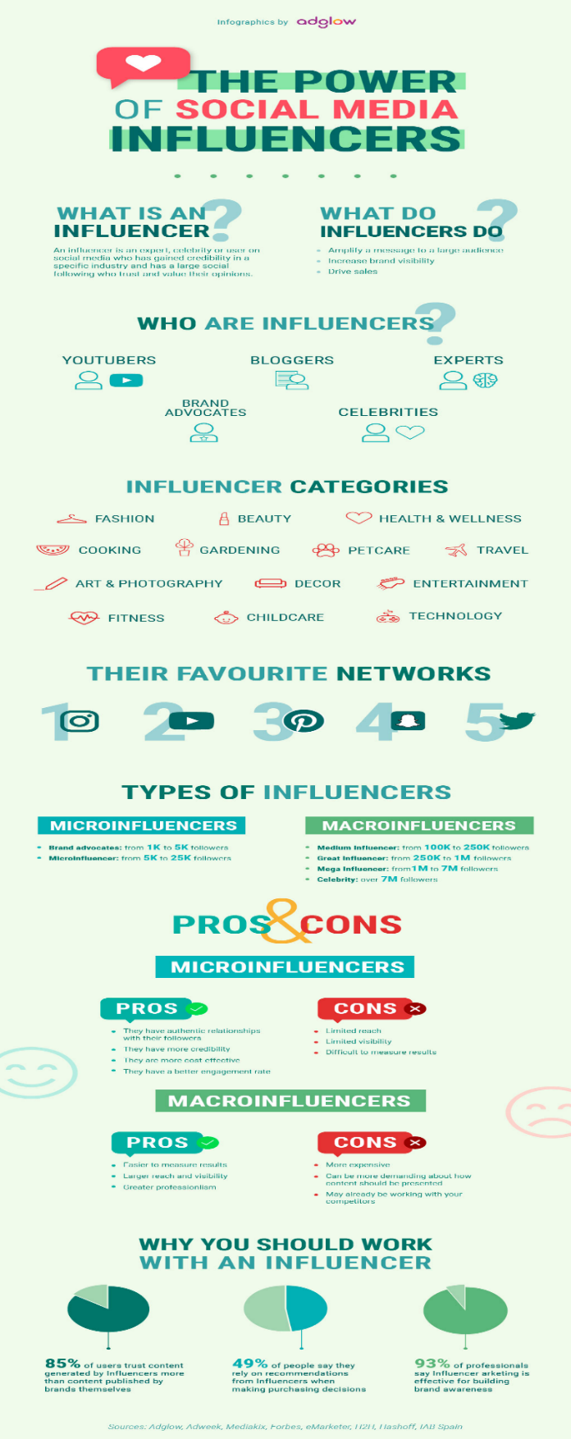

5.2 Appendix 2: Loyalty: Seven steps to heaven (CEO Millionaires)

